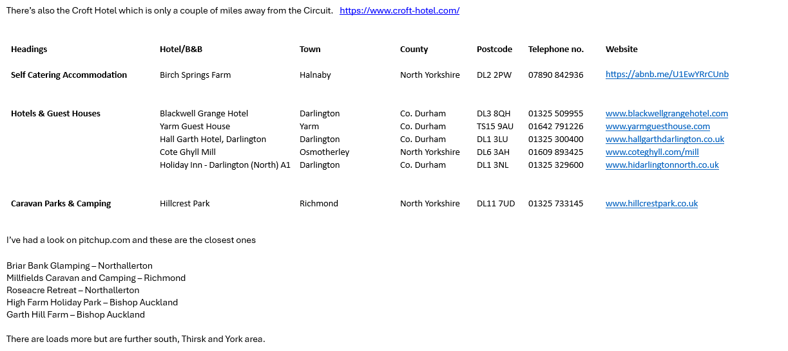

Accommodation & Hotels in Darlington - This is Darlington
This is Darlington - Darlington Accommodation, Restaurants, Entertainment
Camping
Church Holme Camping at Danby Wiske | Quality campsite in Church Holme
440 campsites to discover in Croft Circuit, North Yorkshire | Camping found near Croft Circuit

