MG CAR CLUB HISTORY
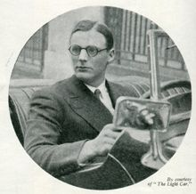
The first complete MG Car Club History was compiled by the late Mike Hawke and published in 2000 to celebrate the 70th Anniversary of the Club. The book was soon out of print, there was clearly a need for a replacement and Peter Browning volunteered to edit an enlarged and updated version. This is the first of a multi-part series.
It is a little over six years since I put together a page of readers’ correspondence for The Light Car including the letter that started it all. It appeared over the signature of one Roy Marsh and was published in the issue of September 5, 1930.

Why Not an MG Club?
Being a very interested reader of The Light Car and Cyclecar, I notice that a number of one make clubs have been formed lately with very satisfactory results. Now Midget enthusiasts, what about an MG Car Club? There are hundreds of you and surely some very enjoyable social runs and trials could be arranged. Perhaps MG owners would let me have their opinions on the idea.
Quite brief and to the point, it took immediate effect. That was as inevitable as the subsequent growth of the Club. You cannot have a lot of people rushing round the country in cars like MGs without wanting to get together.
Various people wrote to various other people. HM Post Office was enriched by numerous pennies inserted in numerous slots and one or two more letters appeared in The Light Car. The upshot of it all was an announcement in that journal of an inaugural rally on October 12 for the purpose of formally bringing the Club into being.
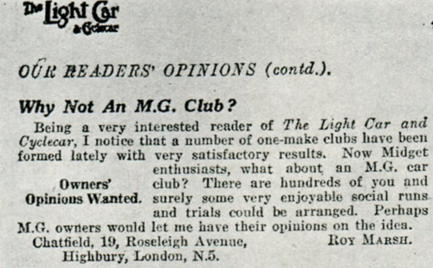
It was part of my job, of course, to keep in touch with events. That would have applied to the formation of any motor club. In this case, however, it was not so much a job as a joy because I was myself running an M-type Midget and felt just as everyone else felt about those wonderful little motors, terrifically enthusiastic. They were quite unlike anything else in their day and it was not until mine had provided me with well over 30,000 miles of very good motoring that I reluctantly parted with it.
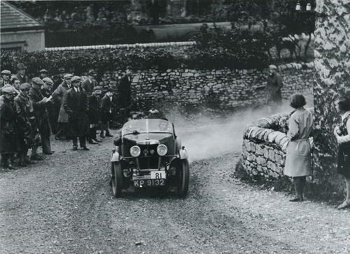The M Type was the start of the Club with a growing number of members competing in trials.
All this is a little beside the point and yet in a way it isn’t, because owners of T-Types and other recent models may not realise that the old original Midget inspired just as much enthusiasm in its time as the T does today.
Anyhow, the rally duly took place at the Roebuck Hotel, near Stevenage (Hertfordshire), on the Great North Road. Over 30 MGs turned up, all but two of them Midgets, and the car park looked rather like the dispatch bay at the works. Inside the pub everyone looked a little awkward, felt it was up to them to do something but didn’t quite know what. Co-conspirators Roy Marsh and John Thornley stepped into the breach, however, and a meeting was soon in full swing. (John Thornley, of course, is the man who now tells you how much it will cost to mend the bits you break, although at that time he had no connection with the works).
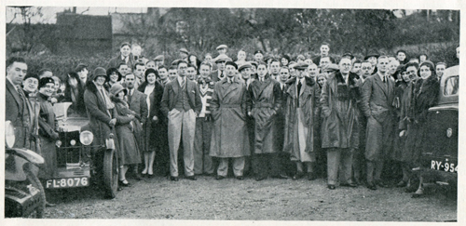The gathering at the Roebuck Hotel for the inaugural meeting of the Club in October 1930
At the meeting, I remember him explaining how he had made contact with Roy Marsh immediately following the letter in The Light Car and offered to take on the duties of secretary pro-tem. On Marsh’s agreeing, he had approached Mr Cecil Kimber and obtained from the MG chief a promise of full support; a provisional design for a badge was also produced for inspection and approved and suggestions put forward regarding subscriptions and so on. He concluded, “If you will let me be secretary for the time being, I think I can make the Club a success,” which, when you come to think of it, was a fairly stout undertaking to make to a lot of strangers.
After a little more discussion, the MG Car Club was formally constituted; Thornley was enthusiastically voted secretary, a committee elected, and everyone sat down to an overdue tea. Forming a club is one thing. Turning it into a going concern is another.
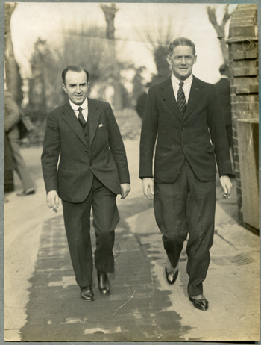
Lord Nuffield (right) & Cecil Kimber were active supporters of the Club
Obviously, the first thing was to give members a better chance of getting to know each other. To this end, another rally was arranged at the Roebuck (on November 9), the plot this time being to assemble for lunch, make a pleasant tour of the countryside in the afternoon, and finish at the King’s Arms, Berkhamsted (Hertfordshire), for tea.
The immediate success of the Club can be gathered from the fact that over 50 cars turned out on this occasion. This large number rather upset the organisers’ calculations and the idea of a convoy run had to be abandoned; instead, members were asked to find their own way to Berkhamsted, which they did by promptly losing themselves and meeting each other going in opposite directions in narrow lanes. The resulting confusion effected a high percentage of introductions so that, by the time the King’s Arms was reached, lots of members knew lots of others and everyone was satisfied.
At Berkhamsted, a member of the local constabulary did yeoman service by standing in the middle of the road and waving members into the hotel yard. This he did with the greatest insistence to every MG that attempted to pass and thereby performed some quite useful recruiting. Thanks to his efforts and the presence of others who had been unable to turn up earlier, the gathering of members and friends at tea numbered well over a hundred.
A week or two later, Thornley rang me up and we met for lunch to discuss the prospects of a trial. The Chilterns (South East England) seemed the obvious district and I promised to find him some hills and draw up a set of regs. Early in the New Year, we got down to the route question in earnest and started a series of extraordinarily muddy expeditions. Arch Mudlarkers were Ernest Wood, the trials secretary, Norman Eames, one of the committee, Thornley and myself. We generally ended up at the King’s Arms wondering whether we were going to be thrown out for carting such large quantities of Chilterns’ chalk into a clean hotel, but a tolerant management put up with us without complaint.
The classic occasion during these expeditions was when we found ourselves stuck in a sea of mud at the foot of Light Car’s Lament just as it was getting dark one bleak afternoon. We couldn’t get up Light Car’s Lament and after making the cars face the other way by dint of incredible effort, we found that they would not go up the hill and would not come down either. Prospects for a good trial seemed encouraging!
Eventually we decided on a course to our liking and some one finger efforts on a typewriter produced a route card that the rest of the committee could understand, so everything was set for the regs to go out and the entries to come in, we hoped.
In the meantime, the Club held its first annual dinner. This took place on January 9, 1931 at the Mecca Restaurant, Ludgate Hill (City of London), with Mr Kimber in the chair. Amongst the guests was the Earl of March (now the Duke of Richmond and Gordon). Mr Kimber made a characteristically amusing speech, gave some interesting facts about the Midget with which George Eyston was even then starting his record breaking habits, and concluded by promising a donation of 50 guineas towards the Club funds.
John Thornley returned thanks, mentioned that the membership figure was nearing the 200 mark and read a telegram from Sir William Morris (now Lord Nuffield, of course) consenting to become Patron of the Club. Everyone was terrifically enthusiastic, and the function registered one more success for the Club.
The affair was also noteworthy as marking the birth of another MG tradition, for an item on the account subsequently rendered by the restaurant read, “To six spoons, bent and unfit for further use, 6s.” or some such sum. (Great oaks from little acorns grow.)
Three weeks later on February 15 the first Chilterns Trial was held. It marked, incidentally, what I believe was the first ban on competition tyres; a ban I had suggested because many members were new to the trials game and might be deterred from entering if they thought it meant spending a five pound note to put themselves on a level footing with the regular trials men.
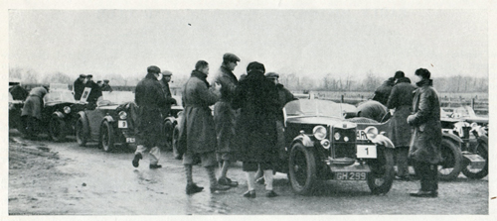
Start of the first Chiltern Trial, the Club's first event February 1931
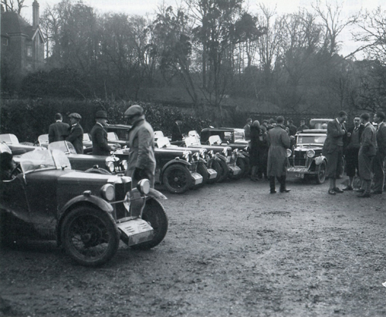
An entry of 60 had been obtained but ’flu was in fashion and 50 drivers actually started, amongst them Mrs. Kimber who drove a Midget, Robin Mere who is now more often organising than organised against, and Stanley Kemball whose office in University Motors the committee regularly borrowed for its meeting.
Here is a brief summary of what happened and where: Start, The Lambert Arms, Aston Rowant; finish, Ashley Green; hills: Lewknor (1 failure); Kingston Blount downhill brake test (24 drivers lost marks); Kop Hill slow climb (30 lost marks including 12 who stopped entirely); Kimble Lane (16 failures); Water Works Hill restarting test (3 lost marks); Hawridge (6 failures); Light Car’s Lament (22 failures). Weather bright sunshine after a week of rain. Best performance, W. H. Haden (Midget); first-class awards 9, second class 13, retired, 1.
Following the event, members adjourned to the King’s Arms for tea and afterwards the annual general meeting was held and brought to an end what, if not a complete year, was virtually the Club’s first season.
One other event remains to be chronicled to make this record of the beginnings of the MGCC complete, although actually it did not take place until May 7, 1932. I refer, of course, to the Abingdon–Abingdon.
The trial was noteworthy first because it marked the beginning of a very successful series and second because it was, I think, the first occasion on which a one make club opened its entry lists to other clubs. In selecting the hills, we were lucky in securing the help of that super trials enthusiast H.P. Baughan of Stroud (Gloucestershire), who has a better knowledge of his own district than any man I have ever met. When we explained what we wanted, he sat down and, without looking at a single map, dictated a route card that subsequently required no correction and very little amplification.
With this basis, arrangements went forward with unusual ease, the only hitch being a panic of major proportions caused, I regret to state, by one H.C. Hastings who had undertaken to obtain all the necessary direction cards from his office and having carefully wrapped them up in a neat parcel, left them in his bedroom at home.
To make matters worse, the discovery was not made until the indefatigable Wood, who had travelled down to Rodboro’ from Leigh-on-Sea (Essex) during the night, arrived at The Bear and roused the culprit from a peaceful sleep at about 6am, by demanding to see the wretched things.
By a stroke of luck, Thornley had put the remnants of a previous trial’s marking in his car. Frantic turning of white cards into red with the aid of a bottle of red ink was needed before the Cotswold end of the route could be marked.
The trial, which started and finished at the MG Works at Abingdon, was run off in bright sunshine and was great fun, particularly an emergency stop test in which competitors, on seeing a notice ‘MG CLUB STOP’, were expected to do so before reaching it. They were, of course, warned of the test, but not its location, and few of them expected it within half a mile of the start when they were still buttoning on their gloves and generally getting comfortably settled. Thornley’s bright notion of having the test so placed resulted in over half the 43 starters overshooting the line. So far as the hills were concerned, here is the list: Wragg hill (restart), Nailsworth Ladder, Quarhouse, Blackness, Mutton, Lies Lane, Besbury Common (acceleration and braking test), Battlescombe (timed climb).
Soon after that first Abingdon–Abingdon trial the Club began to grow very rapidly, which involved a great deal of work for its painstaking secretary. So, having given you my own early memories, I will leave the next stage of this narrative to his very capable pen. Enter J.W. Thornley.
Harold Hastings was on the editorial staff of The Light Car magazine and he put together a page of readers’ correspondence including the letter, which prompted the formation of the Club. As is clear from his report above he played a major role in getting the Club up and running. Harold went on to be the Midlands Editor of Motor magazine and as such was close to the heart of the motor industry. He was a personal friend of Cecil Kimber with whom he corresponded on a regular basis.
Roy Marsh disappeared from Club activities in the mid 1930s. The Club tried to find him, hunting references in London, pouring over street directories and phone books in London and the Midlands, his old London address having disappeared in the blitz. Eventually the Club gave up in despair until a member of the Natal Centre sent to Safety Fast! a small snapshot of an MG bearing a curious MGCC badge of a type that he had not seen before, This car, he said, was owned by a gentleman in Johannesburg who claimed to be a founder member; the badge was the original type and the gentleman’s name was Roy Marsh! He went to South Africa in 1933 and had been there ever since but he had not forgotten the fun he had with MGs back in Britain. He was elected an Honorary Life Member as a small gesture of appreciation of all the pleasure that many thousands of people have derived from the Club that he founded.
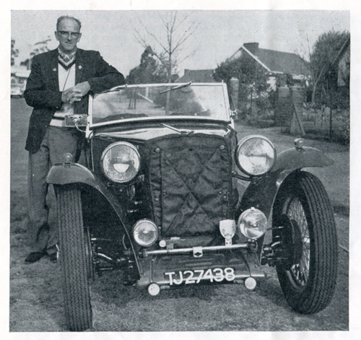
Roy Marsh with his TC in Johannesburg in 1963

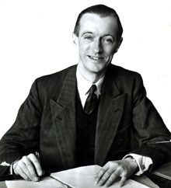
This article covers the year 1932 when John Thornley was Club Secretary.
Forgive me if I do not pick up the threads of these chronicles of the MG Car Club from the exact point at which Harold Hastings left off. I will start in the middle of 1931 when, at the July Open Shelsley Meeting, the Club provided a car park for members for the first time. This, together with tea in the marquee after the climb, was the forerunner of what is now one of the Club’s traditions. Nearly 200 teas were consumed and, whilst the percentage of gate crashers was not computed, it could only have been very small indeed, as every single individual in the marquee seemed to know at least half a dozen others, which resulted in a thoroughly matey affair.
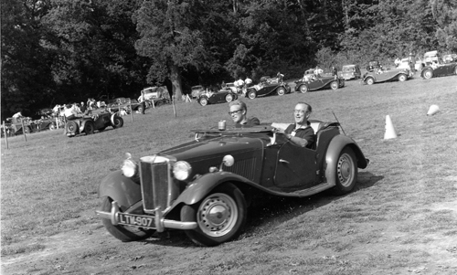
John Thornley with son, Peter, enjoying the 1967 Beaulieu gymkhana
The following weekend the Club registered its one and only really serious failure. An immense amount of care, time and trouble had been expended in organising a trial in the Peak District. Many of the best-known hills were to be used, including Litton Slack and Jenkins Chapel, but the entry was so uninspiring that the event was abandoned.
In the February of 1932 there was held the second annual dinner, also at the Mecca. Well do I remember the beginning of that party. It was apparently a new experience to many of those present, who were used to Club dinners on the grand scale, to go to a Club dinner which was not held at either the Park Lane (London), the Cafe Royal or one of the usual rendezvous, but as they arrived they were obviously wondering what sort of a ‘do’ it was to which they had been brought. They were soon to discover. The party warmed up with very great rapidity and by the time dinner was over and the floor cleared for dancing, things were in full swing. In the course of a recent record attempt on the ‘Magic Midget’, George Eyston had put in an exceedingly fast lap, only to find that the timekeepers had not done their stuff. The scene was accordingly re-enacted after dinner on the dance floor. George Eyston himself, sitting backwards astride a small chair, did several laps of the dance floor, ‘timed’ by Mr H.D. Parker of Shell Mex, who, in this farce, was cast as Colonel Lloyd-Parker, the whole production being ‘under the personal direction of Mr Cecil Kimber’.
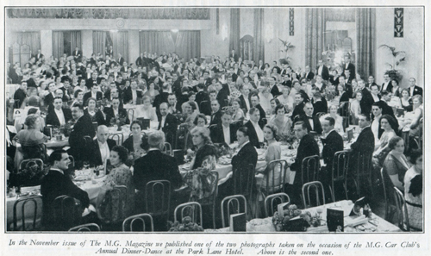Early Dinner Dances were well attended with members in white tie and tails.
On May 7, 1932, was held the first Abingdon–Abingdon. In later years, this trial has gone from strength to strength, until it now appears in the year’s calendar as an undoubted classic. A rare array of trophies attracted an entry of 46.
Starting from the MG Car Company’s works at Abingdon, the route led through many of the famous Gloucestershire hills and returned to the works at Abingdon, where the company had pushed the boat out to the tune of a first class tea for all competitors, friends, organisers, and the like. The MG Challenge Trophy for the best MG Car Club member was won by W.G. Everitt, who has since raced MGs with great success, and has been associated with the road racing circuit at Crystal Palace. The cup for the best visitor was presented by Mr W.E.C. Watkinson to K.W. Bear in a Bugatti. The University Motors Trophy for the best under 1,100c.c. car was won by E.W. Deeley, and we, the organisers, had been so short-sighted in the preparation of the regulations that there was a tie for the P.J. Evans Ltd. Cup for the best over 1,100 c.c. car. This went jointly to H.H. Sewell and E.S. Barnes.
Shelsley appeared again on June 25, 1932 and shortly after, at the end of July, the membership reached 200. The 200th member was no less a man than Maurice Toulmin, though why he was not in the first 50 nobody has yet been able to discover.
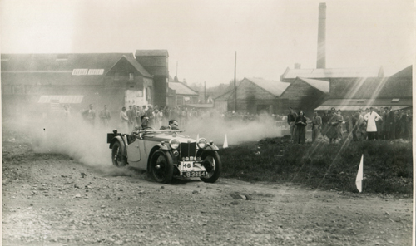
Maurice Toulmin competing in the Abingdon to Abingdon Trial.
In September 1932, Alan Hess took over the secretary ship and, despite a very busy and enterprising year, the balance sheet published at this time showed the very satisfactory surplus of just over 50 pounds.
John Thornley played a leading role in both the MG Car Company and the MG Car Club. When five young men met in October 1930 to form a Club for MG owners the youngster who offered to act as its founding honorary secretary was John Thornley, a 21 year old student articled to one of the leading London accountancy firms who had recently bought an M Type Midget.
The infant MGCC Committee instructed him to seek approval from Cecil Kimber at Abingdon and this he did so effectively that the great man pledged his unstilted support; it marked the beginning of a happy relationship between Club and Company that was to span almost half a century.
Thornley himself wanted to escape the stuffed shirt City atmosphere and his energy and enthusiasm must have impressed the MG boss, for a year later he was given a full-time job at Abingdon as a service department interviewer. Within weeks the service manager was moved to another post and Thornley found himself carrying the can for two not very talented successors. Ironically, he had so much work to do that he had to resign his MGCC post! In 1933 he was appointed Service Manager.
As an army reservist, he was called up on the outbreak of war in 1939 and found himself shouldering considerable responsibilities in the Royal Army Ordnance Corps where he rose to the rank of Lieutenant Colonel.
Returning to Abingdon after the war he became MG sales and service manager. With MGs export sales rocketing, the parent Nuffield Organisation recognised this dynamic individual as a man who got things done and appointed him assistant general manager of both the MG Car Company and Riley Motors when Riley production moved to Abingdon in 1949. Three years later he had become General Manager of the two companies.
He was now under intense pressure to build enough MGs to satisfy the ever growing demand of the time – a demand that surged higher when the MGA was announced in late 1955 and when Austin-Healeys replaced Rileys on the Abingdon assembly lines.
Thornley’s keen interest in motor sport had never wavered. In the1930s he had competed in club events whenever he could find the time, and from 1936 to 1938 he managed the famous Crackers and Musketeers works trials teams.
The MGCC was restarted after the war in mid-1947 and at the end of the year Thornley took over his old position again as general secretary.
John was the one man who stood out amongst the grey-faced nonentities of the BMC management as a warm-blooded human being, well known in the motor sporting world and a staunch advocate of works participation. He was responsible for the formation of the BMC Competitions Department at Abingdon in 1955, and in 1958 he became Chairman of the MGCC, a position he held for 22 years.
In the late 1950s a serious childhood illness returned, causing major surgery and a brave but long convalescence, which finally forced him to retire from MG in 1969. He returned to the fray to do battle against the closure of Abingdon by British Leyland without success.

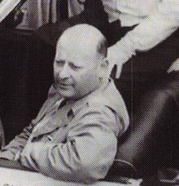
Part 3 of this multi-part series of the MG Car Club History covers the early 1930s. Alan Hess was the second Club Secretary.
Click here to view Part 1 of the series.
When, in August 1932, I was invited to take over the secretariat of the MG Car Club, I did not realise all the hazards involved in what sounded an attractive prospect!
You see, the trouble about being a club secretary is that you are doomed before you start; either the thing is a failure or else it becomes unwieldy. Anyhow, I took over in September and found that the Club had 210 members.
I was fortunate in having around me a committee of enthusiasts. Men who, almost without exception, turned up regularly at our committee meetings, which were held every week at that time. Their enthusiasm and their constructive criticism and practical help were such that by the following April the membership had topped the 500 mark; 194 having been enrolled in 16 weeks.
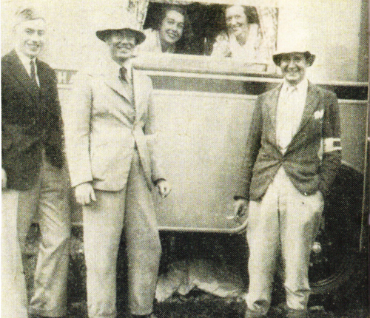
‘Mit’ Harris (centre) 1930s secretary for 8 years with Robin Mere (left) trial secretary & (right) George Tuck.
The first event we ran was a scrounging trial. I remember very well why we chose this type of event as it is a sort of secretary's benefit in that it virtually runs itself!
All we of the organising committee had to do was to assemble our competitors at the start, at Fox & Nicholls' Garage on the Kingston Bypass (Surrey), give each driver a list of the objects to be scrounged, send them off, and then amble at our leisure to the finishing point, in this case the Aero Clubhouse at Brooklands, to await the first arrival and his collection of 'exhibits',
As it happened, there was nearly a dead heat as two cars screamed to a standstill at the finish, absolutely neck-and-neck, but ties were decided on the quality of the articles collected and Strong Foster, the winner, was found to have a worm, which when stretched, measured 0.75 inches more than that of his rival.
The following month l essayed to run a Showtime Dinner Dance at very short notice, The function was held at a London restaurant, and I had been warned that at a somewhat similar function run by another club, substantial damage had been done by certain members who had imbibed too freely, and the club had to foot a large bill as a result. However, I need not have had any misgivings about the MG Car Club members. That was before the days of the memorable down stage parties!
At the beginning of 1933 things really began to hum in the Club. Scottish and Northern Centres had been formed in Edinburgh and Newcastle, and Associate Membership was introduced. In addition to this, negotiations were proceeding for the formation of a Midlands Centre, with headquarters in Birmingham, and the Committee had approved the principle of forming an MG Car Club team to represent the Club in trials, for invitations were pouring in upon us to compete in practically every event held, since our members were dyed-in-the-wool trials enthusiasts. Thus, really, was born the forerunner of the 'Cream Crackers' and 'Three Musketeers' teams, of which you may perhaps have heard.
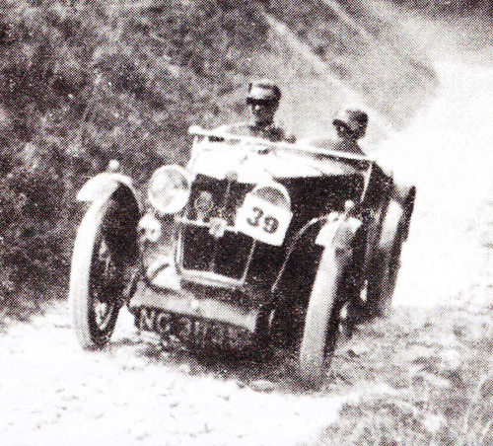
The Marquis Townshend of Aylesbury on Mill Lane in the 1933 Abingdon to Abingdon.
During 1933 the Club held a number of highly successful events of its own. First came the aforementioned Scrounging Trial, then the Chilterns Trial, in April, in which 50 competitors started and more than a dozen finished 'Clean', the premier award going to C.G. Fitt,
The event was not without its minor disasters, however, for the Trials Secretary, an enthusiast named E. Wood who hailed from Leigh-on-Sea (Essex), ran a big end on the way home, and was towed 80 odd miles, while l had to abandon my car in Chesham with distributor trouble, arriving home at 4am in a borrowed car, which, I may add, called for a considerable crop of explanations.
That a club secretary's lot can sometimes be fairly strenuous is indicated by a weekend in the following July, which sticks out in my memory. It was proposed to run a team of L-type Magnas in the relay race later that month, and there was an inter club meeting at Brooklands on the 8th so it was decided to let me enter one of these cars for a three lap event that afternoon to get the feel of it.
I duly turned up at Abingdon in my own car on the Friday morning and left it there, departing inflated with pride, in the L-type. Having tried not too hard, and finished sixth at Brooklands the following day, I drove the car straight from the track to Surbiton (Surrey), where I picked up G.G. Zeigler (a most valuable committee member of the period) and dashed to Beaconsfield (Buckinghamshire), whence we were starting our night trial.
Driving all night, we called at the intermediate time check at Winchester (Hampshire), and thence repaired to the finish and breakfast at Petersfield, immediately after which we turned the hard-working Magna's nose northwards and ran up to Birmingham where the newly formed Midland Centre was running its first affair, a gymkhana, on the Sunday afternoon. Very tired, but glowing with a feeling of unctuous rectitude, we arrived home at about 1am on the Monday morning with the prospect of a week's work in store!
The Relay Race went off according to plan, and the Club team, comprising Charles Martin, G.W.J.H. Wright, and the writer, won. The same team with L.F. Welch, the (then) Earl of March, and T.H. Wisdom as co-drivers ran in the BRDC 500 Miles Race the following September. Martin and Welch captured second place and the team lost the Field Team Trophy by only 26 seconds.
On September 9, the Club held its now famous Abingdon-Abingdon Trial, the team prize being carried off by a Singer Nine Team. G.A. Forbes (K3) won the MG Challenge Trophy, and W.G. Everitt (L-type Magna), now a director of the Crystal Palace Circuit, gained the P.J. Evans cup for the best performance in a car up to 1100cc.
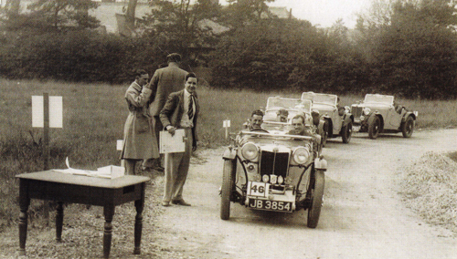 George Tuck meeting and greeting at the start of an Abingdon-Abingdon trial.

About this time, realising that even members of the MG Car Club may have their secret vanities, I conceived the droll notion of instituting Club colours and a Club tie. This is now a familiar spectacle at all the better functions, and I never see one of these confections without a pang as of a father whose child has just passed him by without the faintest glint of recognition!
By now too, The MG Magazine, a forebear of The Sports Car was going strong, and the Club's events were copiously and fairly accurately reported for all to see. The result was an ever-growing membership, very largely contributed to by the local Centres which were going great guns and running a number of very successful competitions and social events.
October 19, 1933, saw the first MG Car Club Annual Dinner and Dance at the Park Lane Hotel and the first function of its kind (much copied by other clubs) at which speakers were regulated by automatic lights. The cabaret that night comprised Elsie and Doris Waters, John Tilley and the Western Brothers, and a good time was had by all!
Early in the New Year at the Annual General Meeting I tendered my resignation and 'Mit' Harris was appointed. During my 15 months of secretary ship I met many fine sportsmen and had the privilege of co-operating with the best bunch of Committee men and Local Centre officials any Secretary could wish for, but before closing I must pay an especial tribute to one man who was always a positive tower of strength and absolutely tireless in his efforts for the Club. That man's name is George Tuck.
Alan Hess was an MG enthusiast with talents as a journalist, fiction writer, painter, broadcaster, and race driver. At the time when he took over as the second Secretary of the Club, he was editor of The MG Magazine. He had raced at Brooklands with a team of Magnas and he also drove the Magna on the 1931 Alpine Rally. Ln later years he became Publicity Manager for the Austin Motor Co and is remembered for his record-breaking drive around the world in 21 days in an Austin 440 Sports.
Frank 'Mit' Harris was the third secretary of the Club, taking over in 1934 and serving for 10 year. At the time he was proprietor of The Sports Car magazine in which he regularly reported MG Car Club news and features. His enthusiasm for MG saw him as an active competitor and event organiser as well as maintaining the job of Club secretary through the difficult wartime years. He retired from the RAF as a Wing Commander and died in 1945 at the age of only 4., His wife Mary was actively involved with the Club; in the immediate post-war period she was responsible for helping get the Club underway and ,in more recent years she donated the Mary Harris Trophy, which remains an annual award with the MMM Register,
George Tuck was one of the founders of the original Club and was involved with the motor industry and MGs throughout his working life. He was interviewed by Cecil Kimber in 1929 to join the Sales and Publicity office of MG and was appointed Publicity Manager in the following year. George's name was linked to the design of the original octagon. He introduced the Safety Fast! slogan and handled the production of MG technical literature and advertising cop. George was responsible for establishing important dealerships in Europe, and after the War these outlets directly resulted in American Gls buying the early TCs there resulting in the wave of enthusiasm for MGs in the US market. He later joined the Nuffield organisation as the representative for Europe and Africa, the USA, and the Far East. He became Export Director for BMC in 1952 and was later promoted to General Manager of BMC Southern Africa. He retired in 1969 to live in South Africa and was elected a Vice President of the main MG Car Club as well as being a long serving President of the Combined South African Centres.
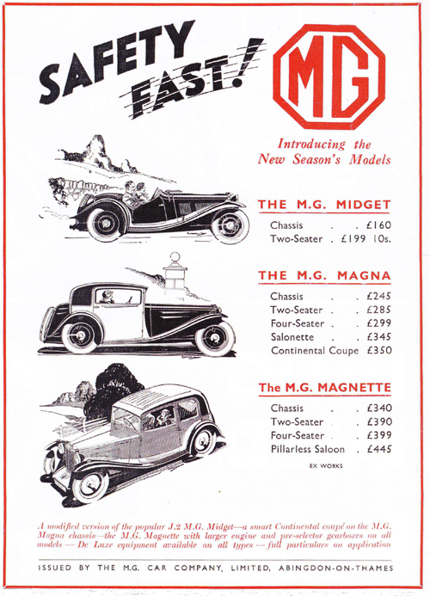
An advert from the September 1933 issue of The MaGazine showing the Safety Fast! slogan.

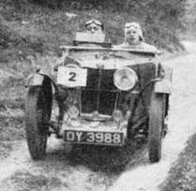
Part 4 of this multi-part series of the MG Car Club History covers the period from 1933-1939 and the growth of the Centres. Alan Hess and ‘Mit’ Harris were the Club's Honorary Secretaries.
From 1933 the Club had a regular monthly news section in two magazines, firstly The MG Magazine followed in 1935 by The Sports Car. The Club news pages were compiled by the Editors who also happened to be the Club's Hon Secretaries at the time - Alan Hess and later F.L.M. 'Mit' Harris.
The following unedited extracts from these monthly reports cover the years 1933 to the outbreak of War in 1939 and illustrate in particular the growth and strength of the Centres.
May 1933: Alan Hess in The MG Magazine. The amazing rapid expansion of the MG Car Club in the last few months is a universal topic in motor club circles today. At the end of last September, we had 210 members. As this magazine is closing for press, we have topped the 500 mark and we are now easily the second largest one-make Car club in the world. Since January, 194 new members have enrolled and the Club has extended its activities by the formation of Scottish, Northern and Midlands Centres. Of these, the Scottish Centre is at present the best supported, having a membership of no fewer than 56. With the expansion of numbers in the Club has come, we are pleased to be able to report, a considerable increase in enthusiasm among the members. Trials and rallies are becoming much better supported with the natural result that we are fortunate enough to receive a large number of invitations from other clubs to compete in their events.
May 1933: The Club's Half Day Chiltern Trial took place in April and afforded a number of surprises to all concerned. The competitors were surprised that two of the hills proved so stiff and the other six so easy while the officials were astonished that the competitors found six of them so easy and the other two so stiff! The critics were not justified in view of the fact that out of exactly 50 competitors a dozen got through to the finish without losing a single mark.
May 1933: The Scottish Centre's first event took the form of a Half Day Trial. A circuit of 10 miles had to be completed twice at an average speed of 20mph. The route covered 14 miles over unmade roads while the rest of the route was on main roads. Owing to the wet weather the minor grassy roads proved really difficult and accounted for several failures while an additional feature of the test, sealed speedometers, made the circuit extremely hard. An acceleration and braking test completed the trial.
November 1933: The Northern Centre held a delightful Dinner Dance in Newcastle-on-Tyne. Dr Crosthwaite, Chairman of the Centre, was master of ceremonies, while the immensely popular and hardworking Secretary, Frank Scott, ably supported him. Mr Cecil Kimber was present and made a characteristically witty speech while the Club's Hon Secretary, Alan Hess, also attended.
January 1934: The Midlands Centre held its first Dinner Dance in Birmingham in November and a right merry party it was! George Propert from Abingdon represented the President of the Club and the Hon Secretary of the Club, Alan Hess, was also present. In the course of the speeches both visitors paid tribute to the rapid growth of the Centre under the capable direction of Mr J. Kemp.
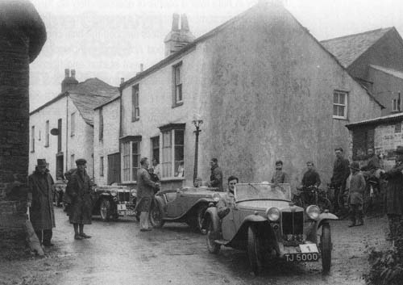
Lands End Trial 1934. MGCC A-team at a halt.
March 1934: At the Annual General Meeting of the Club, held in Hatfield, the Hon Secretary Alan Hess handed over to F.L.M. ('Mit') Harris.
April 1934: The Scottish Centre held an extremely sporting trial early in April over a course of approximately 85 miles. At the time there was some six inches of snow over most of the course and only seven of the 18 starters reached the final check on time.
April 1934: Another good Abingdon to Abingdon Trial was held in April and as usual the event started and finished at the Works after a sporting scramble around the principal Cotswold Hills. There was a record entry of 127 starters, of which 29 gained premier awards and 44 second class awards. In spite of fierce competition from other leading one-make clubs, MG owners featured very prominently amongst the list of winners of premier awards. A new trophy put up by Mr Cecil Kimber for the Club's lnter-Centre competition was won by the newly formed Manchester and District Centre. Robin Mere, the Club's Hon Trials Secretary, was in charge of the organisation and was widely complimented on the manner in which the event was conducted.
May 1934: 'Mit' Harris reported that the Club continues to make very gratifying progress. The recently formed Manchester and District Centre now has a membership of 73 and an attractive list of fixtures. In April, the Centre held a speed trial in conjunction with the Southport Motor Club, held on Southport sands with events run over a straight mile and a five-mile lap.
September 1934: In August 23 members took part in an organised visit to the Ulster TT. In view of the cost being only four guineas including all meals and transit, it is expected that there will be a larger party for a repeat trip in future years.
November 1934: A trip to Le Mans in 1935 is being planned and involves the booking of an exclusive railway sleeping car to take members to the course and to stand there in a siding as a Club HQ while the race is taking place.
November 1934: In September, the Club's Shelsley Rally and Rushmere Hill Climb was held. For the rally, a total entry of 38 was received with converging routes on Shelsley for the Main Club, Scottish, Manchester, Midland and Northern Centres. On the day following the Rally, the Club's Rushmere Hill Climb took place near Bridgenorth over a motorcycle switch back trials course. Cars ran in pairs over the 350 yards course, which defeated a number of drivers.
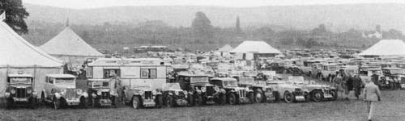
The Club's car park at Shelsey Walsh in 1934
November 1934: There was an attendance of 315 at the Club's Annual Dinner Dance held in October at the Park Lane Hotel in London with Lord Nuffield in the Chair. The gathering included representatives from every Centre of the Club and proved a very successful and enjoyable occasion. Mr Cecil Kimber was present and outlined various high spots of the past competition year.
March 1935: The Club's Chiltern Trial was held in January, the 57 starters gathering at Lewknor, and the two principal hills were Pryton and Crowell, both of which caused a large number of failures. The course consisted of two laps of a 26-mile circuit; the two named hills were tackled twice. The Midlands Centre won the Team Award.
April 1935: This month saw the first edition of new The Sports Car magazine, which was to take over as the official journal of the Club from The MG Magazine. The editor was 'Mit' Harris, also now the General Secretary of the Club. With Club news now monthly in The Sports Car which would be mailed to all members, it was hoped that there would be much improved communications to members.
May 1935: At the Club's Annual General Meeting held in London in March, the major business was to ratify the proposal that the Club should become the MG Car Club Ltd to protect the liability of members. At the same meeting it was noted that John Thornley was appointed a member of the Competitions Committee.
August 1935: The Northern Centre's Lakeland Trial held in June was based in Keswick and started with an impromptu hill climb over the Honiston Toll road. This was a climb of about 500 yards with several acute bends, finishing at speed through a challenging narrow gateway. Competitors returned to Keswick for a lively Dinner Dance. On the following day there was a cruise on Derwent Water followed by a driving test and then a series of trials climbs. The weekend was a voted a great success.
September 1935: Some 50 members attended the first General Meeting of the MG Car Club Ltd held in lvinghoe in July. Mr Cecil Kimber chaired the meeting, which lasted only 10 minutes, after which everyone adjourned for an impromptu hill climb nearby on private ground owned by a committee member. The entry fee was 6p and everyone could have as many runs up the hill as they wished. Some 67 ascents were recorded with the fastest being the General Secretary, 'Mit' Harris in his P Type Midget. However, amid some good humour he was disqualified when it was known that his car was supercharged!
November 1935: The club arranged an exclusive car park at Shelsley Walsh, which at a recent meeting proved extremely popular. There were 128 MGs in the enclosure and some 250 members, and their guests availed themselves of the buffet in the marquee kindly sponsored by the MG Car Company.
November 1935: The Manchester and District Centre’s Cockshoot Trial in September had an entry of 47 cars. Competitors and marshals gathered on the Saturday for an impromptu dinner and party before the trial commenced on the Sunday. Heavy rain the previous week had made conditions difficult.
January 1936: The third Annual Dinner Dance of the Midlands Centre took place in Birmingham in November attended by 150 members. The Hon Sec of the centre, Frank Kemp, reported that membership was now 124 and during the past months his members has collected 26 cups, 41 premier awards, 4 team trophies and 71 other awards in open competitions.
February 1936: Over 100 members were present at the Manchester Centre's Dinner Dance held in December. This was in spite of very severe weather including a dense fog, which prevented many members from attending. Mr Cecil Kimber arrived late because of the weather; usually travelling in his favourite N Magnette, he had to take a train which was four hours late. During the evening, tributes were paid to Lord Nuffield whose ability and generosity had enabled him to make benefactions equalling many millions of pounds. He had given young men and women of the country an opportunity to enjoy manly and healthy sports personified by the events organised by the MG Car Club.
February 1936: Associate membership of the club for those who do not drive an MG was introduced this month at 10s 6d. Associate members can later transfer to full membership (15s); while full members who sell their MG can stay with the club as associate members.
March 1936: The club's fourth Chilterns Trial was held in January. The event was run in true winter weather and the full 57 miles of the route were extremely difficult. The 45 starters included teams from the Manchester and Midlands Centres who had to drive through fog and blizzards to reach the start in Marlow.
March 1936: The AGM of the Manchester and District Centre took place in February when an important proposal was passed. In view of the expansion of the centre (now 136 members) the Centre's name was changed to a more representative one. Accordingly, the centre became the North-Western Centre.
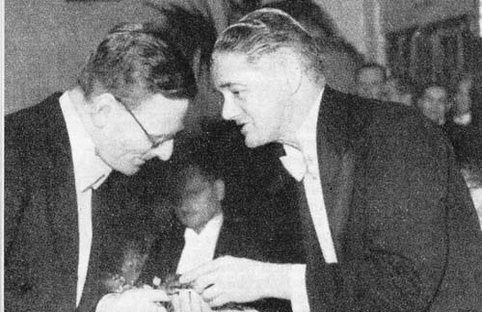
George Hall, NW Centre Secretary, receives a pair of gold cuffs link from Lord Nuffield
April 1936: The AGM of the club was held at the Holborn Restaurant in London in March. Amongst general business, the report and accounts showed a paid-up membership of 627 and a balance of income over expenditure of £43. lt was suggested that there might be some division of the profits accruing from competitions to the provincial Centres. However, as this source amounted to only £18 it was agreed that all funds should remain to increase the Club's reserve.
May 1936: A special enclosure was reserved for members at Donington for the British Empire Trophy in April, members being able to watch the racing from their cars. Unfortunately, so many members attended that the enclosure was full when Mr Cecil Kimber arrived, and he had to park in the next door Talbot enclosure!
May 1936: Arrangements are going ahead for the formation of a new Centre of the Club in the Northeast. It is planned that members of the old Northern Centre will be attached to this new Centre and if possible, a Newcastle Branch will be retained. The Club also sees the room for a new Centre in the west, based in Exeter, Bristol or Taunton, and local MG owners are being contacted.
June 1936: The Annual Abingdon-Abingdon Trial took place in May, starting as usual from the Factory with a running buffet provided by the company. A novelty this year was a special driving test held in the works grounds before the 110 competitors set off on a 45-mile run before the first of the trials hills.
July 1936; A meeting at the Grand Hotel in Harrogate in May saw the formation of a new North-Eastern Centre of the Club. An enthusiastic and experienced Committee was formed, and the new group expects to attract a large and sporting membership.
September 1936: The newly formed Ceylon Centre held its first event in June which was a hill climb in Bandarawela. The hill, which climbs to 4000ft over three-quarters of a mile, provided some thrilling sport.
November 1936: The organisers of the Scottish Centre's Trial held in October earnt special praise for the expert marshalling. Each driver was met at the foot of each climb by a marshal who knew exactly what had to be done because he had personally driven the climb earlier in the day.
November 1936: The Cockshoot Trial run by the North-Western Centre is now an MGCC classic event and attracting 57 competitors with entries from North-Eastern, Midlands and Main Centres. The event was based in Buxton with a Dinner Dance on the Saturday night before the trials action in the Derbyshire countryside on the Sunday.
November 1936: A meeting was held in Bath in October to inaugurate the new South-Western Centre. Some 30 members were present, and Mr Cecil Kimber presided, and presented the new Centre with an annual trophy, and generously brought the assembled gathering a celebratory drink!
January 1937: ln contrast to the traditional formal black-tie Club dinners, the Club's Down-Stage Dinner held in November was an uproarious occasion. Held appropriately in the giant restaurant in London's Zoo, 300 members gathered for an evening with a difference. Mr Cecil Kimber sportingly took the Chair and performed miracles in keeping the party in reasonable order - he blew a trombone in order to gain silence when required. The toasts were led by a group dressed as vicars drinking milk; barrow-loads of pith #####, streamers and paper hats and false noses were delivered. The cabaret was performed by a troupe of pavement artists, pit-queue performers and street musicians who were much appreciated. In closing the evening, Mr Kimber hoped that the bill for broken crockery and so forth would not be too excessive!
February 1937: The new South-Western Centre held its first trial on Boxing Day for the Cecil Kimber Trophy. The 21 starters enjoyed the challenge of local hills in wintry conditions - the route running from Bath to Bruton.
February 1937: Highlight of the North-Western Centre's Annual Dinner Dance was the presentation of the Nuffield Gold Cup to be held for the ensuing year. The Cup (valued at £250) went to the Centre because it had been judged to show the most meritorious growth, enthusiasm, and enterprise during the 1936 season.
March 1937: An editorial in The Sports Car this month reported on the problems of trials organisers imposing handicaps or bans to prevent certain cars from bagging all the principal awards. The consequence has been that regulations have been studied with great care by shrewd drivers who have driven either blown or unblown according to their views of the equity of the handicap. Now Mr Kimber has come up with a handicapping graph for the use of all trials organisers. This graph enables a fair and simple handicapping system to be evolved for any kind of test and any type of car; and will be used in the MG Car Club's next Abingdon-Abingdon Trial. The editor commented that it was good that efficiency in terms of power output per unit of engine capacity is coming to be regarded as the prime requirement of a successful sports car. By this means, trials can serve a useful purpose.
April 1937: More than 80 were present at the first Dinner Dance of the South-Western Centre held in Bath in February. Mr Kimber spoke of the splendid progress, which the Centre had made in the short time since it came into being. He was very gratified to see the strength that the Club was gaining, with nearly 1,000 members. He was very proud to announce that more MG cars were now being exported to America than any other British car.
June 1937: The Sixth Abingdon Trial was held in May and as in previous years the course was principally in the Cotswolds. The organisers decided to make this a tough event and included the most difficult climbs providing they were not likely to do too much damage to the cars. Considering that the event was held in brilliant sunshine the number of failures was remarkable, justifying the comment that this was the toughest Abingdon yet. Results announced at the finish at the MG Works over tea showed that the MGCC had won the Team Award. It was noted that there were 16 T Types entered which showed up remarkably well.
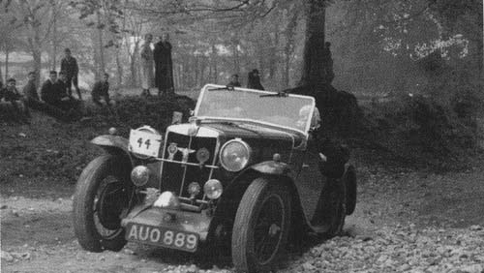
MGCC Abingdon-Abingdon Trial 1937, Nailsworth Ladder
August 1938: The 24-Hour Rally organised by the North-Western Centre in June was a novel event. This appealed to owners of MGs other than trials specials and attracted an entry of 38 cars. Various driving tests were set around the route. The new T Types accounted for a dramatic rise in Club membership (now 1,450 in June) and T Type drivers took the major awards in the 24 Hour and 12 Hour classes on this event.
September 1938: The New York branch of the Club is reported as going from strength to strength with the arrival of more new MGs from the UK. Wherever members go they are questioned by motorists about the little British sports cars and they have prepared information cards that they hand out to in response to enquiries. This also gives details of the local MGCC activities.
December 1938: The South-Western Centre AGM was held in Bath in October with the Secretary, John Siddall, reporting that the Centre for the second-year running was runner-up for the Nuffield Gold Cup. During 1938 the Centre's events had not received the support that they deserved but the outlook was very good for 1939. The treasurer reported that the Centre had now been operating for two years and had nearly £25 behind them. Cash in hand and in the bank accounted to over £20.
December 1938: Once again the Club's Annual Dinner took place at the Park Lane Hotel in London during the Motor Show and was widely described as the best party during the Show week, with some 380 members attending. Mr Kimber welcomed the special guests who included Lord Nuffield, Lord Howe, Sir Malcolm Campbell, George Eyston and Major Gardiner. Tuio Nuvolari was due to attend but was delayed reaching the UK on time. Lord Nuffield presented his Gold Cup to the North-Eastern Centre and used the occasion to make a widely reported speech about the current political situation. A truly memorable evening.
January 1939: The Midlands Centre held their Annual Dinner Dance in Birmingham in November when some 160 members and friends spent a very uproarious evening. Mr Kimber presided and said that he always associated the Midland Centre with a particularly marvellous lot of girls. He congratulated the Centre on having such wonderful sisters, wives, and girlfriends - to say nothing of the feminine members. Mr J. Kemp, the Centre Secretary, responded by saying that the best reason for joining the MG Car Club was that it made you realise and understand what good fellowship really means. With the rapid development and establishment of so many overseas branches, a member would soon be able to be sure of a welcome in any part of the world, which he visited.
January 1939: The fifth Annual Dinner Dance of the North-Western Centre was held at the Mere Country Club in December. Mr Kimber and Mr George Tuck attended from Abingdon and Mr Kimber mentioned that he felt particularly at home at NW Centre parties because he spent all of his early days within a few miles of Manchester. He spoke at some length of Major Gardiner's recent records, commenting that they were witnessed by the technical representatives of Auto Union and Mercedes who were greatly impressed. He said that it was intended to attempt 200mph on the new autobahn near Dessau in the spring.
January 1939: Scottish Centre members were in fine spirits for the Centre's Annual Dinner dance at the Grosvenor Hotel in Edinburgh in December. Mr Kimber welcomed the 150 members and regretted that there was no tartan with an octagonal pattern - if there was, he would have been in a kilt.
March 1939: The North-Eastern Centre held its annual Dinner Dance in Harrogate in February. Major Gardiner was chief guest and received an engraved silver tankard including the Yorshireman's Coat of Arms. Centre membership was now over 150 and on display was the Nuffield Gold Cup recently presented to the Centre.
October 1939: With the outbreak of War in September, the October issue of The Sports Car was the last to be published, with a lengthy statement about the future of the Club and some interesting comments by editor and club secretary, 'Mit' Harris, which are reproduced below.
"With the outbreak of War, the MG Car Club is in a state of suspended animation as far as Great Britain is concerned. All forthcoming events are cancelled. This decision has been taken because probably more than half the members have left their normal peacetime occupation or will be doing so shortly. News reaches us every day of prominent members who have joined up in the forces as full-time jobs. Many officials from the centres have joined up but their records are being kept and their trophies, for example, guarded by the Club headquarters (the magazine office in Holborn, London)".
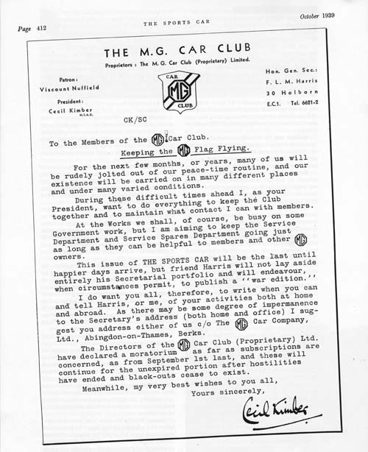
The magazine included a statement from Cecil Kimber written on MG Car Club headed notepaper

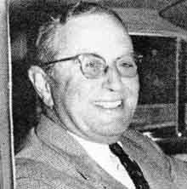

the periods from 1945-1950 and from 1950-1959, the re-birth of the Club following the end of the World War II, and the growth of the international markets. John Thornley and Russell Lowry were the Club's Honorary Secretaries.

John Thornley
Before considering the post-war re-development of the Club, it may be as well to back track a little on the state of the country, the state of motoring in general and of MG in particular.
When the war finished cars of any kind were not numerous. Those, which were running mostly exhibited pitiful evidence of six years of minimal maintenance. Those, which were in mothballs, were in a condition, which was proportionate to the expertise of the person who had devised the method of preservation. Tyres were a severe problem. Petrol was rationed at a meagre level, a restriction which persisted until the end of the decade.
The MG Car Company, Abingdon, had been heavily involved in war work, employing some 1,600 people on a wide variety of projects, while its car making equipment, such as it was, was stored away in a warehouse in another part of the town and which somebody set on fire in 1943. All the exotic stuff, parts of K3, Q and R, bronze cylinder heads, twin-cam conversions and a host of development materials were in the basement, which of course, filled with water from the fire hoses.
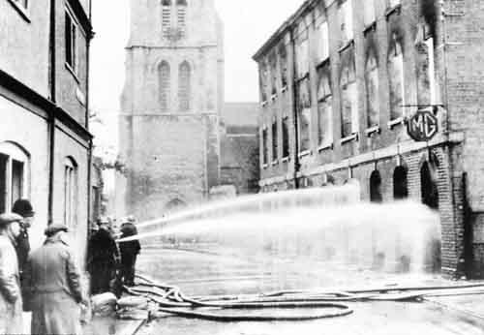
The Abingdon warehouse fire in 1943, which saw many rare development & racing parts lost
Subsequently, because of the exigencies of war, concrete was poured into the hole rather than that time should be wasted in attempting salvage. lf any wealthy enthusiast would care to buy a block of flats and then bulldoze them; I think I could show him where to start digging!
Miraculously, almost all the tools, which had produced the components of the TB, including the body, survived in various Nuffield organisation plants and it proved to be possible to have the beginnings of TC production in the last days of 1945. (As it was only in the May of that year that the Nazis had collapsed and August when the bombs fell on Hiroshima and Nagasaki, somebody at Abingdon had moved pretty fast).
Even so, the UK market in MGs was not, of itself, such as to generate any great enthusiasm. The nation was living through the period when the catch phrase was "Export or Die". The number of TCs and Y-types, which appeared in the middle of the following year available to be sold in the UK market was directly related to the number of cars which we could export. The miserly ratio, controlled by our allocation of body sheet, was of the order of one home car per twenty exported. Small wonder we had a real good go at the USA!
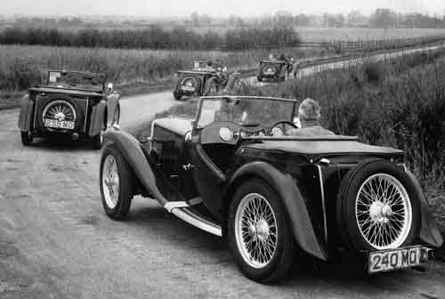
Export T types destined for the USA to join the growing number of Centres set up by Russell Lowry
But now, back to the Club. During the war Hector Cox, MG's peace-time sales manager, had been a caretaker general secretary. Nothing creative was done, of course, and the work consisted mainly of replying to the letters, which those delightful enthusiasts or “nuts", according to which way you looked at it, wrote to the Club from time to time.
When I re-joined MG late 1945 or early 1946 (so help me, I can remember the salary but not the date!) one of the first things l did was to re-employ MG's first customer G. S. (Jack) Gardiner as personnel manager and transfer the job of general secretary of the Club to him until such time as we could re-establish some ground organization.
Our pre-war general secretary, Frank 'Mit' Harris, had died in the latter days of the war but his widow, Mary, who had always been a bright light in Club affairs concurrently with 'Mit' reappeared in the London centre and, in no time at all, there was an active committee, with Stanley Kemball as chairman and with Mary, Robin Mere, Stew Morgan, Walton and myself, among others, as members.
Petrol shortage virtually prohibited vehicular sport, so the forerunner of the present noggin and natter became popular, variety being added by rallies on the Underground! I can't quite remember how they worked, but Stew Morgan has reminded me of an occasion when a piano appeared on the platform of, we think, Holborn tube station and a singsong persisted half-way to Ongar.
Gradually, possibly one should say rapidly by today's standards, things improved, The Company got its teeth into the American market, production improved, cars became available to the home market, enthusiasm re-kindled, the provincial Centres came to life again, new ones erupted, the pre-war membership level was reached and passed.
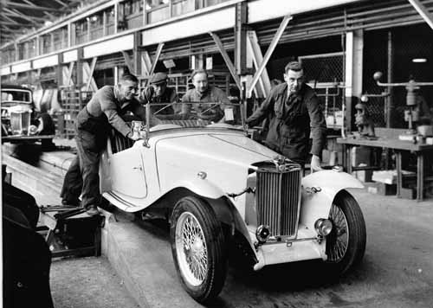
The last MG TC Midget coming off the Abingdon Assembly Line in 1949
Motorsport began again. The MG Car Company participated officially, in a very limited way, in motor racing. The team of Jacobs, Phillips and Lund ran Ts and Ys at Dundrod and in the production car races at the BRDC Silverstone meetings. The pre-war Abingdon-Abingdon Trial was replaced by a gymkhana held within the perimeter of the Abingdon factory, the Company providing, inter alia, refreshment on a lavish scale such that this event rapidly became a major social occasion. It was at one such that I met Russell Lowry.
Lowry was a retired broker from the Liverpool Cotton Exchange who, from his youth, had pursued motorsport on two, three and four wheels, and was well involved in motor club life in the North of England. In the doldrums period he had started, written, edited and published a magazine called The Motor Club, which had a good circulation in the North, and, what is important from our point of view, was taken by our North-Western Centre, which led to a friendship between Russell and Brian Norris.
The rapid growth of the MG Car Club had produced a workload which was clearly beyond the part-time capacity of an ever busier executive of a thriving company, and it was clear to me that it was of little use shifting the job to some less loaded person within the Company; Company affairs would always be given precedence and the Club would come nowhere. It was necessary to find a secretary outside. But who?
Russell had, for some time, been collating news of MG Car Club affairs for inclusion in the Nuffield Organisation magazine Motoring. In the matter of The Motor Club, Russell had been in touch with Dennis Poore and The Motor Club had become our old friend Autosport, edited by Gregor Grant, with Russell Lowry as Northern Editor and, within its staff George Phillips of immortal MG memory as official photographer, and an enthusiastic Ulster man, F. Wilson McComb, as one of its scribes.
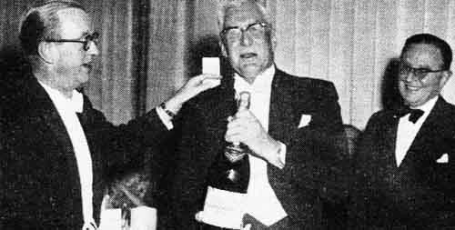
John Thornley makes a presentation to George Eyston. Russell Lowry on the right
At the BRDC Silverstone of 1950 one buttonholed Russell Lowry, twisting his arm until he agreed to become General Secretary of the MG Car Club. To my shame, he reminds me now that my then estimate of the extent of his labours would be "about one day a week". With the growth of the Club overseas and its mounting success at home and, be it added, Russell's ability to push things along, it soon became a full time job and, what is more, we seduced Wilson McComb from Autosport to come to Abingdon and edit Safety Fast!. But the rest of the story is better left to them.
Jack Gardiner was a junior salesman in Morris Garages in 1924 looking forward to his 2lst birthday on March 14. The birthday he knew would bring with it a useful little sum of money, so he asked his chief to build him a special bodied Morris. Cecil Kimber agreed and in due course Gardiner took delivery of his Morris Garages Special (FC5333). It was first registered with the Oxford Licence Authorities on March l3 the day before his 2lst birthday. Gardiner could certainly claim to have been Kimber's first retail customer. Gardiner was later appointed Personnel Manager of MG and served for a year as the Club's Secretary.

Russell Lowry
When John Thornley made me General Secretary of the MG Car Club in the summer of 1950, with effect January 1 1951, I had already been in touch with Club affairs for quite a while and had been reporting regularly in the New Outlook on Motoring, which was quickly ridiculed into just plain Motoring. We had one page (yes, boy, use both sides) on which to circle the world. So, one of my first battles, which was to last nearly 10 years, was for more space. Eventually we won. The result was Safety Fast!
During these early days it seemed odd to me that the home Centres had practically no contact with each other and indeed, at Council meetings, some of them were barely on speaking terms. Local autonomy and local pride were valuable things in themselves, but a wider canvas was needed. Gradually it got woven. We wheedled some trophies out of the Nuffield Organisation for three regional rallies embodying an element of friendly rivalry and hospitality. The first all-Centre meeting was run at Silverstone in August 1951 and was very popular though organizational difficulties persisted. These days the Cobbans appear to carry Silverstone with all the ease and grace of Atlas doing a wheel change, but among those who really put this meeting on its feet one name, which must always be remembered, is that of Mary Harris. Nor should Wilf Hale and his Midlanders be forgotten. When finances became tight, they swore Silverstone could be run without loss. And they did it. So, although in the 1950s new MGs for the British market were few and far between, the Club grew, soon exceeding its pre-war membership, and without losing its local flavours acquired a taller standpoint and a wider view.
Contact with the Home Centres was quick, easy, and good, perhaps the more so as, based on Liverpool, l wasn't too far from any of them. Overseas affairs were much more complex and difficult. It may be hard to realise today, but motorsport at club level was practically unknown in the outside world until it arrived on the shuddering springs of a TC from Abingdon. The seedling took root and grew mightily, but frankly nobody knew quite what to do with it. In the USA, for instance, the sport had no governing body so there were no "competition rules". Lovely, says you? No sir. You cannot have a sport without rules. Blinding glimpse of the obvious. But that's how it was, nearly everywhere. So, we had to improvise.
A system of recognition, with a rather nice certificate signed by John Thornley and myself was devised. This conferred, as it were, sovereignty within its own area and no poachers would be recognised.
Centres drew up their own rules, based in the main on those of the parent Club, but submitted to them for approval. Ideas varied enormously. I recall one Centre, which specifically banned the carrying of firearms during Club events. Another admitted no women (heaven help them, that country is now in a fever of equal rights!). A third (purported to) forbid alcohol on competition days. One felt rather as, I suppose, a doctor must feel at a birth; a desire and determination to help, some experience and some knowledge enabling one to do so, but a sense of awe coupled with excitement and fear in case things went wrong.
That bit of atmosphere must do duty for a mass of detail. We did what we could we already had, but found more, friends in high places who helped us without expecting the Club to be turned into a publicity stunt, or a private army, either of which we knew would destroy it overnight. People who didn't see things this way had to be resisted with tooth, claw and maybe the occasional arrow. We had our successes and, goodness knows, our failures but it would seem that we built pretty well.
Present day paper shortages are probably due in part to the enormous exchange of mail with distant parts but there was one Centre, which appointed a secretary especially because he couldn't write! It was all good clean fun, with a serious purpose. I evolved an unlimited range of signatures with faces pleased, faces angry, faces pleading, coy, hearty, and disdainful. And one that cried when it apologised. R was a useful initial.
The soundness of the overseas foundations is surely proved by the superstructure of hospitality, co-operation and friendship which has arisen on them, starting perhaps with the gift, by Long Beach, of the California Cup to the parent Club, then developing into the pattern of co-operation that exists today and about which one reads in Safety Fast!. Long may it continue.
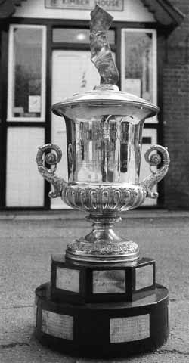
The California Cup, a gift from the Long Beach Centre
If l am to be remembered at all in the line of general secretaries, I would like it to be as the chap who nailed rule 2(a) to the mast, the rule declaring that the object of the Club was "to further the interests of the owners and drivers of MG cars" and who clung, sometimes against bitter opposition, whether in the UK or overseas, to that doctrine. The chap who (except under the Dead Bodies, Crossing Over of Act) would not allow us to become just another motor club. I believe that policy to have been right. I inherited it, believed in it, observed it, and passed it on.
Somewhere, on a sideboard, or in a shed, is a piece of silverware called the General Secretary's Cup. In 1951 nobody needed to know that it was a purely personal gift from me to the Club. We were not really short of cups. It just seemed a nice idea to me, as a newcomer.
Now, nearly 25 years later, I can say that I'd like it always to be won by a member driving an MG, an MG made at Abingdon, as long ago as reasonably possible.
John Thornley penned this tribute to Russell Lowry. After the end of World War, the Home Centres of the Club had come to life again after six years of hibernation. The British had embarked upon their export drive, and MGs had begun to flow in ever-increasing quantities all over the world. MG Car Clubs overseas had begun to erupt spontaneously, and the Club as a whole was an amorphous selection of Centres with a total membership, based on estimate rather than known fact, of some 2000. I had been trying in a very part-time capacity to pick up the various threads and attempt to tie them together. It was at this stage that Russell came upon the scene.
He was a self-confessed ex-cotton broker, with a certain amount of time on his hands. For years he had been interested in motoring and motorsport on two, three and four wheels, and had, prior to my meeting with him at Silverstone, been publishing a magazine called The Motor Club with a wide circulation in the North-West of England. Some of the MG Car Club Home Centres had been in touch with him, and were contributing to this magazine, and there were thoughts of it becoming the official organ of the MG Car Club. In this same August of 1950, however, Autosport started publication, and this incorporated The Motor Club. Russell becoming the Northern Editor of the wider journal, his knowledge of motorsport, his quite brilliant journalism and his manifest liking for the MG Car Club fitted him exactly to the General Secretary's chair.
From the moment of his taking up the secretarial pen he has harnessed and developed the Club's affairs as few others could have done. While the MG Car Company has been distributing and exporting its cars, Russell has been distributing and exporting the goodwill of the MG Car Club to the point where there are now some 8000 members throughout the world. Though he has visited many Centres of the Club, this coordination of what may justly be called the MG Brotherhood has been achieved primarily through the medium of correspondence.
During the past 50 years or so many have said that letter writing was a dying art - that the day of 'belles lettres' was past. Russell is the shining example of the exception to this. Letters and memoranda from him on a wide variety of Club topics reach me at least every day - thorny problems, requests for guidance, masterly expositions of intricate overseas affairs, items just for information; each one a sheer joy to read. All over the world from Long Beach to Long Island, from Melbourne to Singapore, from Durban to Amsterdam, and from London to Edinburgh, there are those who derive pleasure from these letters of Russell's, whether he is patting them on the back for some good piece of Club work, outlining some point of policy, or taking them to task for stepping out of line.
A classic scholar derived from a linguistic ability which would be the envy of many, and a knowledge of the not-so-dead languages, is an enormous vocabulary which every so often, it seems, is insufficient, so that he coins, concocts or generates a new word of his own - at once apposite and immediately intelligible - to keep pace with our rapidly developing complex world. This wide choice of words, the deft twists of phrase, the use of the unexpected and the novel - all done, one feels, with a whimsical smile on his face - make the reading of his letters an exciting adventure. The sure knowledge of his subject, the warm understanding of the human problems involved, and the restraint with which, always, he will express his point of view, combine to inspire confidence and establish a lasting bond with those fortunate enough to be on the other end of the line.
Thus, it is that countless MG Car Club members in the far corners of the world will, on a visit to England, direct their steps, as a first priority, towards Rose Cottage, Nest Wirral, the Lowry home. There they will meet Meg, his wife almost as much a part of the MG Car Club scene as Russ himself - and be absorbed – that is the word - into the Lowry ambience. They will discover that the man they have known as the writer of "these letters" is even more real in three dimensions, and that Meg, with her knowledge and viva is the fourth.
This is the foundation on which the International MG Car Club has been built. The great majority of our members have not been able to meet the Lowrys - the more is the pity. But perhaps from what I have said they may now be able the better to appreciate that they are members of a unique organisation which, while finding its common ground in the ownership of or interest in a fine car, has developed through the sympathetic understanding and single-mindedness of Russell Lowry.

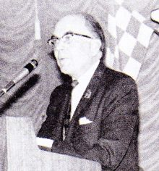

History covers the Sixties from 1959 - 1969. Wilson McComb established Safety Fast! in 1959 and subsequently became MG Car Club General Secretary in 1963.
When I came to Abingdon in February 1959, I found a brand-new office awaiting me within the MG factory. I was surrounded by delectable new sports cars, and I drove them far and fast (for there were no overall speed limits then). My days were devoted to producing a monthly magazine for enthusiasts like myself and it was my good fortune to have as my chief, John Thornley, who expected me to get on with the job and assumed (since he had chosen me for it) that I knew what I was doing. The evenings, as often or not, would be spent browsing through dusty files in the always-fascinating study of MG history. And before long Gordon Cobban, with almost incredible generosity allowed me to use his MGA for races, sprints, and hill climbs, I could say that this was the happiest period of my life, and it would be the truth.
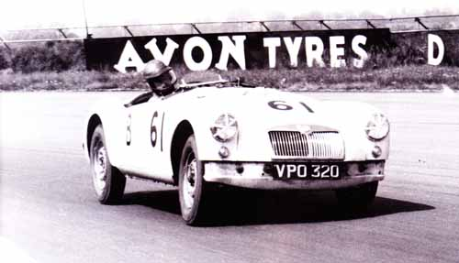
Wilson McComb racing Gordon Cobban’s MGA at Silverstone 1959
But not the whole truth, because life isn't like that. In the men's room of a certain New York restaurant there used to be a sign that read, ”We aim to please. You aim too, please”. ln editing the original Safety Fast! I also aimed to please.
The trouble was, there were so many folk to please: MG Car Club members in Britain, on the Continent, in the USA, or Australia, or South Africa, or wherever; MG owners who were not Club members at all and saw no reason why they should be; ex-MG owners who were to be wooed back to the fold, if possible; and that always incomprehensible bunch of non-motoring, non-enthusiasts, the management of the British Motor Corporation.
They, since they were paying the pipet rather naturally wanted to call the tune. I was expected to make enthusiastic noises about all BMC cars, even the horrible ones. I was instructed to form an Austin-Healey Club, which would share Safety Fast! as its official organ. Many an MGCC member protested loudly, for the Club subscription had gone up from 25/- to 35/- (remember those funny old shillings?) and the reasoning was: “It's our magazine, we're paying for it, and we should decide on its contents.” Actually of course, the extra ten bob covered little more than postage, and the magazine was heavily subsidised by BMC (as was the Club itself).
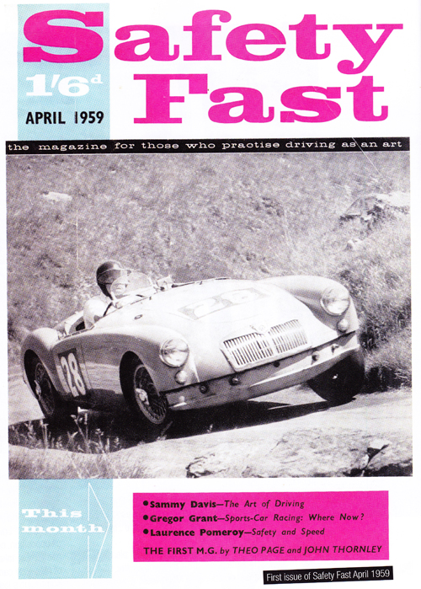
First issue of Safety Fast April 1959
So, while Safety Fast! radiated confidence and contentment, there were many problems beneath the surface. Especially there was a shortage of suitable MGs for Club members, the revived Midget being still in the future and the lamented ZB having given way to the less popular Mark lll Magnette. Even MGA sales were a bit dodgy; they picked up with the announcement of the new 1600 model, but soon fell away after that. And MGCC membership reflected the same pattern: for over several years the numbers fell both at home and abroad after reaching a peak of 7,500 (3,000 home, 4,500 overseas). The heaviest and most lasting blow fell abroad, where the figure stabilised at about 3,000 members, although the number of Centres actually rose.
Russell Lowry's courageous adherence to rule 2(a), despite all opposition, certainly weeded out a host of non-MG owners who had almost taken over the Club in some places. The justification of his policy came shortly after his retirement, for by 1964 all the Home Club's losses had been made good.
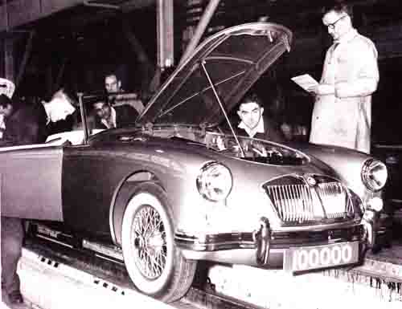
The 100,000th MGA coming off the line in 1962.
Another important factor was the successive appearance of the new Midget (mid-1961), the MG version of the 1100 (late 1962), the MGB two-seater (late 1962) and GT (late 1965). By 1967 the home membership was well over 5,000, by 1968 it was 6,000, and there were eight Centres plus two sub-Centres in the Home Club, no fewer than 43 overseas Centres, and 500 unattached overseas members. 0ver 9,000 altogether. We in Britain had become particularly chummy with some of the overseas Centres, and the Club was doing very nicely, thank you; this despite (or more probably because of the fact that from early 1964 to mid-1967 I had been mainly occupied by my work as press officer to the all-conquering BMC rally team of Hopkirk, Makinen and Aaltonen in their fire eating Mini-Coopers. Then, just when everything in the garden was lovely, the very thing that Russell had always feared started to happen.
Following a change of BMC top brass, a most determined attempt was made to utilise the Club for a mammoth, worldwide MG selling exercise. To emphasise that MGCC members are not unpaid MG salesmen, the appropriate number of digits was displayed to BMC.
Now, this is a dangerous game to play at any time. It was perhaps unduly tactless to make such a gesture early in 1968, only a few months before BMC so suddenly turned into BLMC, because that little development led to our being weighed in the balance and found wanting.
So poor old Safety Fast! got the chopper and before the end of the year the Club's financial backing was withdrawn, and l, having been axed, returned to my freelance typewriter. If Russell wants to be remembered for his back-to-MG policy, my deepest satisfaction comes from remembering that more than 15 years ago I foresaw the increasing interest in early MG models and supported the Register cause on every possible occasion.
Wilson McComb arrived at MG in 1959 to start up the new Safety Fast! magazine, and by the time he left Abingdon ten years later he had become without doubt the most authoritative MG archivist and historian.
Born and brought up in Ulster, educated at Queens lJniversity, Belfast, his early love of cars and Irish motorsport led him to work as local contributor to Autosport, later becoming assistant editor and to work as a motoring correspondent for the BBC in Northern Ireland. He progressed to be editor of the prestigious Auto course annual and it was his style of writing that caught the eye of John Thornley who was on the lookout for someone to launch the new Safety Fast!
Wilson soon found himself in his element with the challenge of establishing the new magazine but he also realised that, apart from the original pre-war chassis files and some incomplete and often far from accurate production documents, there was no official MG archive.
Research was meticulous and time consuming and Wilson would never publish facts or figures until they had been crosschecked every conceivable way. He was well aware when interviewing older members of the Company whose memories were fading that their stories always had to be double-checked with other sources. As his articles appeared in Safety Fast! these prompted contact with people far and wide, many of whom had lost contact with Abingdon, and Wilson never lost an opportunity to welcome them back to the fold.
As the magazine for the MG Car Club, it was not long before Wilson was corresponding with owners all over the world on all sorts of subjects, not the least of which were technical queries, and he took it upon himself to become the 'factory customer help desk'. And if he did not know the answers himself, he would always find someone who did.
When Russell Lowry retired as MGCC General Secretary in 1963, Wilson moved on from Safety Fast! to take on the job, which he did very effectively for four years before handing over to Gordon Cobban. During this period, he was also appointed BMC Competitions Press Officer and regularly travelled with the team on races and rallies, keeping the media fully informed of the teams successes.
The BL takeover of MG, and the final closure of the factory and the withdrawal of support for the motor clubs, brought a sad end to Wilson's time at Abingdon, He retired to Chichester to pursue his love of boating, where he died of a heart illness in 1989.

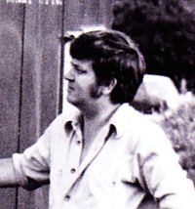
Part 7 of this multi-part series of the MG Car Club History covers the late Sixties from 1968 - 1970. Martin Brent was MG Car Club General Secretary during this turbulent period.
When British Leyland closed down Safety Fast! and the MG Car Club operations, as one who was most intimately concerned in both events, I must tell the story as it was and record the immense contribution that one Gordon Cobban made to the future of the Club.
What really happened is that in the summer of 1968, shortly after we had learnt that Safety Fast! was to be chopped and replaced by the new Leyland magazine High Road, Wilson McComb called Les Needham of the Austin-Healey Club, Maurice Burlon of the Mini 7 Club and yours truly, who was dealing with matters pre-1955 MG, into his office and broke the news that the car clubs were to be axed. The reactions varied; Maurice was furious as he had just, that month relocated his family from Essex, while Les was, as usual, calm, and collected. Me - well I wondered what the future held for me, but I had had a year or two of fun, I was young and in love…
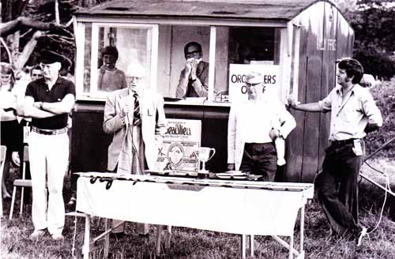
Martin Brent (right) with Gordon Cobban, George Eyston & Lord Montagu at a Beaulieu prize giving
Wilson next spoke with me about the future of the MG Car Club and related the discussions that he had had with John Thornley. It seemed that JWT (who was very poorly at the time) was looking at ways to save the Club and had been talking to the Club's elder statesmen, particularly Gordon Cobban, then Secretary of the South East Centre. As I recall, Wilson was not terribly happy about Gordon's plans for the continuation of the MGCC and had his own ideas.
Wilson was playing his cards close to his chest, but I know (because I saw the final draft of his proposals) that he had discussions with the VSCC about their structure and how it worked. Wilson's proposals were based on that sort of structure, suitably modified to cater for the existing structure of the MGCC, and envisaged a new Club office staffed by Wilson and myself, aided and abetted by Margret O'Brien who was supremo in the Club Office, dealing with membership administration. The Centres and the Registers would continue but the Registers might have had an enhanced role. The finances seemed to add up and Wilson worked it up for a meeting with JWT and Gordon when the matter was to be discussed.
I can clearly recall the afternoon of that meeting as Gordon burst into the office with a big grin on his face and, as he passed my desk, said, "Don't worry, it's all in here.”
What transpired at the meeting I knowest not, but Wilson returned somewhat downcast and Gordon ####-a-hoop. Whatever happened, Wilson’s proposals never again saw the light of day. Shortly after this I was called to JWT’s presence and asked about my personal future.
The simple stark choice was to either take the MG files to Cowley and continue my service work from there or to hand the work over to the MGCC Registers and be relocated at Abingdon doing something else. If the latter, what did I want to do? I said that I did not want to go to Cowley and that I would like to stay at Abingdon - perhaps try my hand at factory planning - which is how I eventually found myself in the work study section!
Wilson, too, was looking to his future, and amongst other things he mentioned that he had been approached by the Montagu Motor Museum about employment but had decided to go off and finish his magnum opus - MG by McComb - and then freelance.
The decision made on my employment, JWT asked me to discuss the handover of the files and the service enquiries to the Club. I thus found myself talking to Gordon and Mike Allison and it was agreed that Registers would, in future, deal with all pre-1955 service queries addressed to BMC/BL. One of the associated matters discussed was the security of the files, which had, until then, been very secure with only the Car Club office staff having access. These files, in two filing cabinets, contained a huge collection of MG memorabilia started by George Tuck and added to over the years by his successors and by Wilson, Mike and myself.
One of the joys of working at Abingdon was that employees seemed to hoard everything from pre-war service tools, which were still available on loan to staff, to manuals, publicity material and pictures.
The arrival of my VA in the factory car park was used as an excuse by many to clear out all manner of drawers and odd corners greatly to the benefit of the Club, and where there were duplicates, my own personal files. Also, at this time, I was spending a lot of time over at Cowley Photographic going through the negatives of the old drawing office records and listing them (l was also getting a lot of copy material for both the Club and my personal SVW files!). The material in this collection was fantastic - I found many gems, such as Kimber's drawings for his dissertation on style, drawings for models that never saw the light of day and much, much more, mostly, it has to be said, of a fairly mundane nature but of great interest to owners rebuilding their pre-war cars. My only wish was that l could have had more time to go through it properly but, as they say, the clock was ticking.
The two four-drawer cabinets full to the brim with irreplaceable material and previously mentioned, were supplemented by two other cabinets in Wilson's office which were mainly photographs of races, trials, hill climbs and other events that he had assembled over the years as Editor of and subsequently as Gen. Sec of the Car Club. Why all this detail? Well, read on.
I don't know why, but the agreement with the Club was that the two primary filing cabinets and the individual model files were to be handed over to the Club and that the Club was to be responsible for their security. All other material was to be disposed of or reallocated. It was at this time that Wilson and I had our one and only really memorable argument. He suddenly told me that as Secretary of the Vintage Register, he felt that the Members of that Register were getting a raw deal and that he was contemplating either persuading the members to go independent or to join the VSCC. I was strongly of the opinion that the crisis facing the Club was such that we needed solidarity rather than divisiveness and told him so in no uncertain terms. To say that he went ballistic is an understatement but typically, after we had both shouted at each other for a few minutes, it all blew over and by the afternoon all was back on an even keel and the Vintage Register stayed with the Club - for the time being.
It was shortly after this that Wilson went off on leave, the other occupants of the office were relocated, and I was left with the melancholy task of watching over the clearance of the Club and Safety Fast! offices. A skip arrived and the stuff that went into it was astounding. The collected junk of 25 years was dragged out of corners and after a quick look to see if it might be needed, it went either into a box for safe keeping or into a barrow and thus to the skip. So much of it would now be priceless to the collector. When I saw the two supplementary filing cabinets from Wilson's office heading for the skip, I moved quickly to stop the barrow. I asked what was happening, "Mr. Lambourne (then Works Manager) wants this cleared," was the response. Off I rushed to JWT who, in effect, said that he didn't care what happened to those particular files as long as the office was cleared - anyone who wanted them could have them! Remember, he was not a well man and had a lot of other, far more important matters on his mind at the time. Knowing of all Wilson's work on this collection, a telephone call to him at home resulted in the quickest journey from his house in Drayton to the Works on record, and two minutes later the two cabinets were off to safe keeping in Drayton!
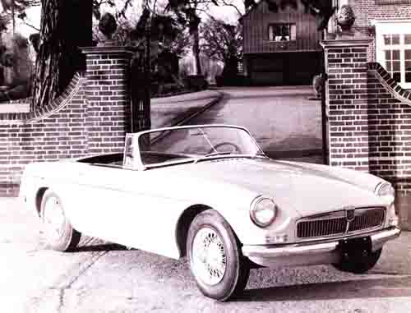
The launch of the MGB in late 1962 helped to grow the MG Car Club membership
While all this had been going on, Gordon had approached me about the Club's administration and had asked if I could help while Margret O'Brien was off sick. JWT had approved my secondment for a few months and I was given two secretaries to help with the initial stages. Gordon felt that it was important to retain the Abingdon connection even down to the PO Box 251 address and had leased the first floor offices over a bank in the Market Place at Abingdon which would be the new Club offices. The following Monday, two girls and I were installed in one room while all the machinery for printing and for addressing envelopes was in another. Further down the corridor were the records, including the by now infamous filing cabinets and files. In retrospect, it was a peculiar period - a feeling of being in limbo as we were so isolated, the only regular visitor being Gordon on his weekly flying visits from Essex, sometimes bringing his wife Elsie with him. If on his own, he and I retired to a pub to discuss business. If Elsie was with him, we stayed in the office!
Whilst in charge of the office I insisted that access to the records was strictly controlled with only individual files being made available for inspection by Club members under close supervision by one of the staff. Nobody but nobody - except the staff - was allowed in the filing room and it was on this aspect that I differed from Gordon. It must be remembered that Gordon was a Centres man to his fingertips and believed implicitly that the strength of the Club was in its Centres. Registers were to him a bolt-on goodie and must not be allowed to become too powerful to the detriment of the Centres. In truth, he was not particularly interested in the history of the Club or the cars and could not really appreciate my concern for the files. I believe that after my return to the factory unrestricted access was given to the files, and where they are today is a mystery.
My stay at the new Club office was fairly brief - a matter of two months until Margret O’Brien came out of hospital and was fit enough to return to work. l, and one of the secretaries, returned to the factory which I found to be an unhappy place. There was a feeling of mistrust and everyone at section head level or over seemed to spend a lot of time watching their backs. Nobody knew where we were going, and nobody seemed to have any authority to decide things. We were reduced to paying for a temporary typist from petty cash because all expenditure on staffing had to be approved at top level and it took forever to get a decision.
There was no sense of direction; no planning for the future and, looking back, the management was poor, bordering on the inept. We just went on producing more MGBs and Midgets in the same old way. There was no money for investment; all our proposals for increased productivity on the lines went up to the Kremlin, never to be seen again and the only new car on the stocks that had any hope of production was the MGB VB. The unions were all-powerful, and it was not a happy time - there was not the same atmosphere as in the mid-60s BMC days. The writing was on the wall and I decided that enough was enough and embarked on a new career elsewhere.
And that is what really happened, the MG Car Club offices stayed in Abingdon over the bank until the Club finances dictated that the cost of the offices could not continue, and it was then that Syd Beer appeared and moved all the material to Houghton where it was stored, I believe, in the old bus garage which Syd always hoped would become an MG Museum. Over the succeeding years, the Club has had its ups and downs but the efforts of people like Gordon Cobban must never be forgotten. He, more than anyone at that time, saved the Club. His enthusiasm and persuasive skills enabled us to continue in being. His energy and devotion to the Club was boundless. He so often put his hand in his own pocket and paid bills that rightly should have come from the Club coffers. His life revolved around the Club and its activities and he and Elsie attended events all over the country. I happen to believe that the Club would not be in its preeminent position today without Gordon's contribution.
Yes, he could be assertive and dogmatic but who isn't at one time or another? I did not always agree with him about Club policy or even the day-to-day running of the revamped Safety Fast! of which I found myself Editor, with a minuscule budget and an impossible timetable. Remember the days of letterpress printing with the astronomical costs of plates, which took forever to produce? I well remember the arguments with Gordon about that particular cost heading and the frantic dashes from Oxfordshire to London with pasted up page proofs which Gordon would collect and take to the printers! As I said, Gordon would do anything for the MGCC.
Yes, let us remember famous men; John Thornley and Syd Beer among them, but let us not forget the man who, above all, secured the future of the Club in what was probably its blackest hour Gordon Cobban.

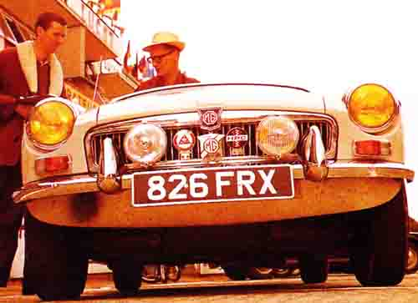
Wilson McComb with his Berkshire registered MGB Roadster at La Mans 1964
Martin Brent is first remembered in 1966 when he tried to get support to form a Register to cater for the, then, unloved by many, pre-war push-rod engine touring cars, which did not sit comfortably with the T-Register, the Triple-M nor the Vintage, which by this time were all firmly established. Martin owned a VA saloon, which was his only car. He lived in Reading and was a work-study engineer with the Reading Council. Following a series of meetings with Gordon Cobban and Wilson McComb, it was agreed to establish the SVW Register with Martin in charge. The Register flourished, and Martin thus became involved with the Club and was a frequent visitor to Abingdon. When Mike Allison moved on from the Club offices, Martin took over his position, but when the Clubs were ejected from the Factory, Martin's previous Council work gave him a natural transition to British Leyland Rate-fixing Department, where he settled, until the mid-71s, when things within BL became unstable and he went to work for Watford Town Council. He sadly suddenly died in the early 90s of heart failure following a move to the West Country.

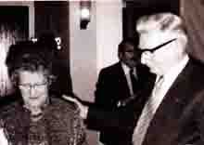
One evening early in November 1968 I received a telephone call from our Chairman, John Thornley, to say that he had received instructions to wind up the Car Club in a manner as painless as possible. My reply was, "We had better get together then." We both felt that ways and means must be found to carry on with the work and achievements of the preceding 40 years.
We arranged a meeting and in the meantime I talked things over with Tom Hazlem, the then Chairman of the South East Centre, so that when I met John I was able to put forward what Tom and I had agreed was a reasonably practical plan for the continuance of the MG Car Club as an entirely independent body.
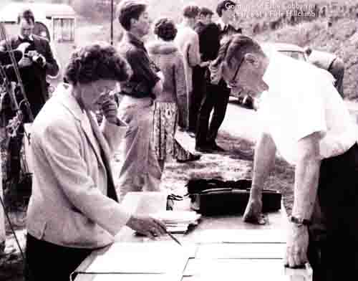Gordon and Elsie Cobban in charge at a Firle Hillclimb
In our opinion, part of the plan hinged upon our succeeding in persuading Margret O'Brien, who at that time had some 15 years' service with B.M.C. and consequently accrued certain pension rights, to leave and come over to our projected independent MG Car Club. At that stage it would have been premature to mention this to Margret. At my meeting with John it was agreed that an ad hoc meeting of the elder statesmen of the Club should be called at the earliest possible moment to discuss the future.
Fortunately over the years a very considerable force of grey haired gentlemen, who really had the affairs of the MG Car Club at heart and at the same time were realistic in their outlook towards motor sport and the MG Car Club in particularly, had become an integral part of the Club.
On Friday, November 15, 1968, the meeting took place at Abingdon and all UK Centres were represented. After John Thornley had outlined the current situation, considerable discussion took place as to the future of the Club.
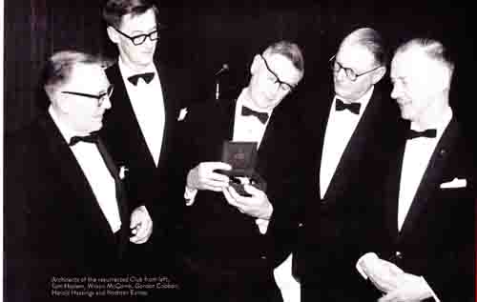
Architects of the resurrected Club. Tom Hazlem, Wilson McComb, Gordon Cobban, Harold Hastings & Norman Eames.
Prior to the meeting Tom and I had burnt a considerable amount of midnight oil in drawing up plans, including financial budgeting, and were firmly of the opinion that whilst a struggle for the first two or three years might well ensue, it was a feasible proposition to go it alone, providing we had the full support of the remainder of the UK Centres. Our plans were discussed and finally agreed, and I came away from the meeting wearing the hat of the honorary general secretary which office I agreed to accept for six months. One of the items upon which much thought was given at the meeting was the method of communication, and it was fully agreed that a form of bulletin covering the whole of the Club’s activities was absolutely essential if the Club was going to be held together; and it was left that we were given the authority to take appropriate action forthwith to get the magazine off the ground.
After the meeting we met Margret and put forward our ideas for crossing hurdle number one and left it with her to sort out in her own mind. From her angle there was much to be considered, and to attempt to arrive at a decision without adequate time to weigh up all aspects could only lead to embarrassment at a later date. Two weeks later we were very relieved to get a "Yes" and plans then proceeded to find suitable office accommodation.
We then approached the second hurdle, which was to devise a suitable Club magazine, and to this end various quotations and ideas were considered. Martin Brent, at that time the Secretary of the SVW Register; was approached and informed that in our opinion he would make a very good editor of the new magazine and that he had better set to work because we wanted the first issue available for the Racing Car Show around January 2. As he didn't put up too good a case for not doing the job, he got it!
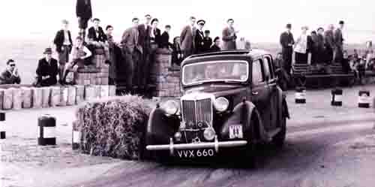
Gordon Cobban with his Y Type on the Western Rally
Frantic discussions took place with British Leyland in an attempt to get their consent to the use of the title Safety Fast! and it was only at the very last moment before going to press that consent was received. We also had a battle on our hands to obtain a licence to continue with the title of the Club as it had stood for the last 40 years, but again in this we eventually succeeded.
With five weeks to go, Martin got down to work compiling the first issue of the new look Safety Fast! and on Boxing Day of that year I met Martin in London. He handed over to me the make up for that first issue, which I immediately took to the printers at Southend, with the result that the publication was on the stand at the Racing Car Show from the word go. This was a fantastic achievement on Martin's part and the Club owes much to him for the initial work he put into the publication, and for continuing as its Editor for the next two years. He then handed the editorial chair to Mike Allison, who ultimately passed it to Steve Glenn.
The first two years of our independence produced considerable concern as to our financial situation; however, thanks to the expert guidance of Tom Hazlem, who had by then become our treasurer we survived. During the first year Tom put in a tremendous amount of work in compiling the Memorandum and Articles of Association of the MG Car Club Limited, so that on October 25, 1969 the Club held the first meeting of the Council of the MG Car Club at the Hyde Park Hotel, Knightsbridge and we were on our own.
Here I would like to thank all of the UK Centre officers and committees for the support and backing they gave during our early years of independence and for the support they continue to give to the present day. So far as overseas Centres were concerned, the majority of them re-affirmed their affiliation to the parent Club and it is encouraging to note that both in number and stature considerable progress has been made during our six years of independence.
Thus, today we have no fewer than 38 overseas Centres which are extremely active, and many support us by forming parties to come over and take part in UK events. There have also been quite a number of very successful visits to the European Centres, which have been supported extremely well and our thanks are due to them for their tremendous hospitality.
To sum up I think that in our independent state our Club has grown in stature and is respected in all fields of motor sport and I would like to thank the founder members of the Club, John Thornley, Harold Hastings, Norman Eames, for the foundations they laid so well and truly in 1930 and upon which the Club today stands.
Gordon Cobban's career started when he worked as a joiner before being called up to serve in the Royal Engineers. After the war he established a successful building company in Ilford, Essex. His interest in motor sport and MGs stemmed from his friendship with locally based Dick Jacobs, and Gordon campaigned a series of cars including YB, TE MGA and a 1300 in national and international events sometimes as navigator in rallies. He joined the MGCC in 1953 and by 1955 he was on the SE Centre Committee and became Centre Secretary in 1958. For a decade he led the SE Centre from strength to strength, handling the organisation of all types of competition events. In 1968 when British Leyland withdrew support from the Clubs, Gordon found himself General Secretary of the whole Club with no office, no funding, no secretary, no way of producing Safety Fast and no authority to continue the use of the MGCC name. It was largely due to Gordon that the Club survived as his office and staff became the Club HQ for some 12 years. He took over the organisation of the Club's races and sprints building up Silverstone in particular and was always supported by his wife Elsie. Gordon died in November 1994.
Tom Hazlem was a keen rally driver in the 1950s and a member of the Council of the then renowned London Motor Club. Here he gained a tremendous amount of experience, not only as a competitor but also as an organiser and administrator. His profession as an accountant and fondness and dedication to motor sport and motor club life resulted in his becoming ever more involved in Club administration. He joined MGCC in 1957 and in 1960 was elected to the South Eastern Centre Committee and after taking a prominent part in the organisation of the Centre motor sport activities, he took over as Centre Chairman in 1967.
Before many months had elapsed the financial problems at BMC began to emerge and these set Tom thinking of the future of the Club should financial and other support be withdrawn. No time was wasted and when the axe fell in November 1968, Tom was able to present to a meeting of the elder statesmen, convened by John Thornley detailed financial and practical plans for the Club to continue independently of works support. The plan was accepted and was the basis of the independent organisation.
Using his wide experience and the knowledge of the pitfalls other similar organisations had fallen into, resulting sometimes in their almost complete demise, Tom spent much midnight oil in drawing up the Memorandum and Articles of Association of the MG Car Club in such a way that the difficulties experienced by others would be avoided.

Bill Wallis – Club President 1996 – 2010
Gordon Cobban acknowledged the part which senior members of the Club, and particularly those from the Centres, played in restoring the Club to a new future after the withdrawal of British Leyland support - Bill Wallis was certainly at the forefront of this revival.
Bill's association with the MG Car Club started in 1948 when he was involved with the recreation of the Midlands Centre after the war. He joined the Centre Committee in 1949 and immediately turned his hand to becoming involved in all aspects of the Club's activities soon becoming Centre Chairman.
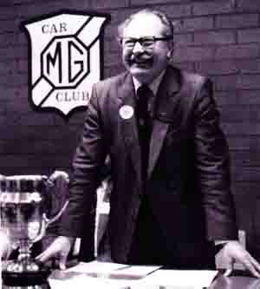
Bill Wallis, Club President for 14 years
He was much involved with the Centre's important role in the marshalling of the Welsh Rally, which later led to similar involvement with the RAC Rally. He became an active RAC scrutineer and took on the post of Clerk of the course for the California Cup driving tests at Silverstone for 17 years.
Bill was asked to take over as Club Chairman when British Leyland support for the clubs was withdrawn, and his skilful handling of affairs during these difficult times did much to help the Club survive.
In 1996 he took over as Club President from John Thornley, a post which he filled with tremendous dedication and enthusiasm for a remarkable 14 years until his death in 2010.
Bill had boundless enthusiasm for being involved with so many Club activities where he was blessed with the skill of always saying the right thing at the right time - and always with great wisdom and sincerity. Bill was always supported by his wife, June, who herself was involved in several Club activities.
It is appropriate that his name will be remembered with the completion of the new Bill Wallis Archive extension to Kimber House.
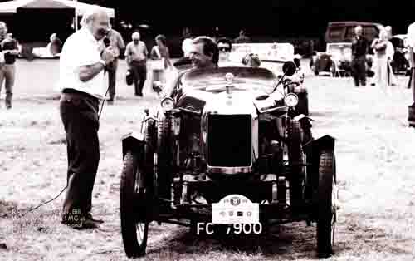
Bill Wallis with Old Number 1 MG at the Abingdon International Carnival in 1999.

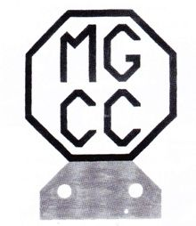
References to many items of the Club's history in this chapter also appear in a previous chapter which includes brief extracts from the Club news pages in The MG Magazine and The Sports Car. Typically, however Mike Hawke researched many of the stories and includes more background information.
The preceding story of the Club tells us a good deal about the events we held and what the members did. It gives little hint as to who did the background work, how it was organised, where the money came from, how the books were balanced, or the legal status of the Club. Indeed, we know little of these subjects, yet they are of vital importance in understanding how the Club evolved and, as we shall see before the end of this chapter they left us with a legacy which influences us today.
At the original Roebuck meeting, a young John Thornley volunteered to be secretary. The owner of an M-type Midget, he was a trainee accountant living in London and attending the London School of Economics.
In those days there were no photocopiers, word processors or other easy ways of producing copies of documents. Even the typewriter was virtually unknown on the domestic scene. Writing a hundred letters and distributing them was somewhere between very difficult and impossible unless you had a good typing pool and office facilities available.
In Gary Watson's video “lnside the Octagon”, John explains how he visited Abingdon most Saturdays on Club business and badgered Cecil Kimber to give him a job because he was finding it impossible to do a full-time job in London and run the Club business from (to be noted) Abingdon. As Cecil Kimber was Chairman of the Club one must presume that John visited Abingdon to get the Club mail which he had drafted during the week typed and distributed. When he was given a job, "on November 3, 1931 and life really began for me", no doubt that secretarial assistance was put on a much firmer footing.
When I first became involved in Club organisation in the late 1950s, life was simple. If you were running an event, you simply sent a draft of the regulations and entry forms to Abingdon and they typed, printed, and circulated them exactly in accordance with your instructions, at no cost to your Centre. One imagines that John Thornley set up the prototype of this system back in the early 1930s.
The Club expanded. Monies involved became bigger. One problem which faces any group of private people conducting an activity is, "What do we do if we run into debt?" Debts can arise from all sorts of unexpected angles. If the creditors call in their dues, the individual members have to cough up. In fact, if the members' pockets are deep enough to cover any possible sort of liability, this may not be considered a problem. In those days people were not so legal-minded and court cases against the Club for such things as possible damage to property as a result of trials activities were considered a remote possibility.
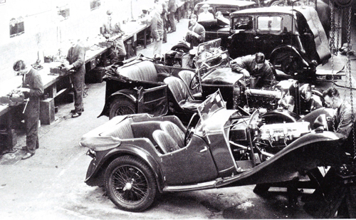
The MG Service Department. Members were offered benefits including spares of up to £5 sent immediately by the MG Works to any MG Car Club members who broke down in Great Britain.
The answer was to make the Club a limited liability company. In April 1935 it was announced that the MG Car Club was now the MG Car Club Limited. The new company was ratified at the AGM on March 15. Having got that important piece of business over; Mr Kimber invited all those present to his club (Gilson's) for a drink. It is reported that on the following morning, various members of the Midland Centre found themselves stranded at stations like Crewe and Stafford, beyond their intended destination of Birmingham, wearing the wrong overcoats, one of which belonged to Mr Kimber!
They had a few parties. One must remember that the membership of the Club tended to be twenty-something. The 1935 MG Car Club Annual Dinner held in London to coincide with the Motor Show was reckoned to have been the best of that particular season. The floor show included the Western Brothers (of at least the fame of the Spice Girls in their day). Apologies were received from Victor Riley and Sir Malcolm Campbell (probably genuine, especially as Sir Malcolm gave the main address at the 1936 dinner). In 1935 he was busy at Bonneville. Apologies also came from Hitler and Mussolini (this is questionable!). Mussolini's apologies included an order for three R-types to keep his domestic pets, Maserati, on their toes. Lord Nuffield was present. His on-the-spot response to this leg-pull is not recorded.
Returning to the sober matter of limited liability companies, members will be relieved to know that their maximum liability to pay off an MGCC company debt is £1 and that they have already put this into the kitty as part of their membership fee.
Regalia, a feature of any club's activities these days (it's good advertising and makes a bit of money), did not flourish in earlier days. Of course, there was a Car Club logo, and a Club badge to put on the front of one's car was available from the very start (pictured above). Designed by John Thornley, it was soon replaced by one in virtually the form we have it today.
It was not until September 1933 that things got moving with the issue of a Club tie. It comprised “a narrow light brown stripe between two thinner old-gold stripes on a dark-brown background”. No MG Car Club badge was in the design, you note. Price initially was 5 shillings (25p) but it dropped to 4 shillings (20p) and then to 3 shillings (15p). Was quantity production bringing the price down, or were they hard to shift? Lapel badges came in May 1934.
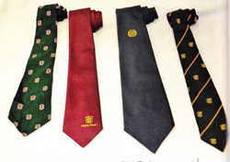
Selection of Club ties
As far as can be ascertained, Club ties with the MG Car Club badge thereon as a motif were not sold until well after 1945 when the post-war recovery was at a point when such minor aspects of Club life could be considered. Indeed, there are indications that the sale of Club items made a very slow restart.
As late as 1951 there were complaints that badges were hard to come by. This was the most important and key item of Club accessories. It could well be that ties with the MG Car Club badge thereon were not available until after 1950.
One of the more curious episodes of Club life is that of associate membership. At a lower subscription, it was introduced in February 1936 and intended for people who did not have an MG. Probably it was aimed at those sporting motorists who wanted to join us to take part in our attractive competitions programme. However, this resulted in the MG Car Club badge being seen on cars other than MGs and someone took exception. An associate members' badge was introduced just like the real thing but in green, leading to the use of the expression 'a green badge man'.
But people changed their car; swapped from MG to something else and back to MG or owned more than one car. A series of announcements in The Sports Car tried to outline the rules for 'proper' and 'green' badges, swapping one for the other etc. Clearly there was much confusion. From this distant point of view, it seems as if this was one of the many unnecessary complications which have ruffled the surface of Club life from time to time.
Perhaps the green badge episode dampened the Club's enthusiasm for regalia. The next item to be offered was a linen MG Car Club badge to be sewn on your racing overalls, quite a few members raced. Scarves followed in 1936.
Some Club arrangements have disappeared, perhaps for ever. For instance, special carriages were arranged on the train which left Euston Station (London) at 7pm on Friday August 31, 1934. Why? So that members could attend the Tourist Trophy Races at Newtonards in Northern Ireland. The whole excursion, including ferry fares, cabins etc cost 4 guineas (£4.20) This was clearly a success for it was repeated in 1935. There was talk of organizing railway sleeper cars to the Le Mans 24-hour Race in 1935 but we hear no more of this one. A trip to the Paris Motor Show of 1937 was offered to Club members. This was cancelled because insufficient applications had been received by the day bookings had to be confirmed. Then a flood of applications arrived at HQ. In some ways members never change. Note that members tended to travel about the country by train if they were not actually on a motoring event.
Members were often offered non-motoring benefits. Some of those to be recorded include: 75% off the prices at Ace of Spades Swimming Pools (West London, I believe); Spares of up to £5 sent immediately by the MG Works to any MG Car Club member who broke down in Great Britain. Pay later. This was then 25% of the price of a new J2, say about £500 at MGF prices; Free parking at the premises of A&D Fraser Ltd, the MG agents, when visiting Glasgow for the Scottish Motor Show; Free membership of the Motor Sports Club, London; Reduced membership fees for the De Havilland Flying School Club at Hatfield.
We now come to a most significant event which is shrouded in mystery. In The Sports Car of December 1938 it was reported that: 'An Extraordinary General Meeting of the Club was held in London on November 7 when a small attendance voted for an adjournment. It is likely that the adjourned meeting will be called for a date in early December'. We are further informed but not entirely enlightened by an item in The Sports Car for February 1939. 'Extraordinary General Meeting. An extraordinary general meeting of the Club was held in London on January 2, when the two resolutions previously circulated to all members were carried unanimously without amendment The old limited company behind the Club is accordingly being dissolved and a new company being formed with articles of association drawn to meet the Club's present and future requirements. No changes in the Club’s domestic arrangements regarding its subscriptions, its Centres, its events and so forth are contemplated.'
What was going on? When one reads in Lord Nuffield's official biography that Morris Motors bought the MG Car Company Limited from Lord Nuffield in July 1935 and, later; the MG Car Club (Proprietary) Limited on January 14 1939, understanding dawns. We were joining the Nuffield Group of Companies. Why? This is not clear. It seems a bit late for this to be a bit of tidying up after the major restructuring exercise of 1935. Anyway, this earlier upheaval had been brought on by Lord Nuffield's tax position and one presumes that the MG Car Club was a minnow in that sort of level of accountancy. Did we need to 'reserve' our office premises at Abingdon? It has been suggested that our sponsoring of the Cream Cracker and Musketeer Trials Teams needed to be put on a stronger basis, this move virtually making it indirectly coming from the Nuffield Group, i.e. an MG Car Club team was virtually a Works Team. One in the eye for Leonard Lord? Perhaps this was why the reports in The Sports Car were so lacking in specifics.
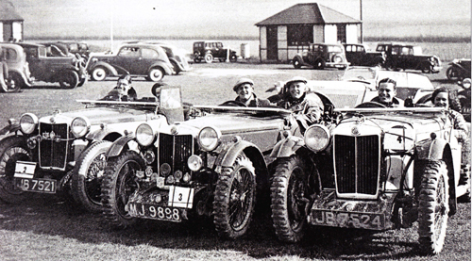
L to R Drivers Maurice Toulmin, Dickie Green and Ken Crawford part of the Cream Cracker Team 1935/36
A much better clue is given in some later correspondence between John Norris of Joseph Cockshoot & Co Ltd (the MG Agent in Manchester) and John Thornley. The MG Car Club had become an important player on the motor sporting scene. It was thus important to the car maker that the activities of a bunch of amateurs (which most of them were and most still are) were carefully monitored. John Norris' words were: '(1) It was possible for the MG Car Company to become involved in legal and moral responsibilities for acts of the Club and its members. 2) Club activities might take a form which was not in the interest of the MG Car Company'.
The carrot for this watchful constraint was assistance both financial and in kind. We took the deal, joined, and remained part of this big corporation, including the British Motor Corporation when it was formed, until 1968.
Elsewhere in correspondence it is said that the MG Car Company had to step into and sort out our affairs in 1964 but I cannot find out why. Incidentally, John Norris became the Clubs first elected vice president, in February 1953. The situation was similar in recent years, even if the method of control differed. To take the most outstanding example, our annual Silverstone Race Meeting is a major event and widely reported. It was sensible for Rover/MG to help with its success and, by doing so, to gain publicity for themselves.
Since the introduction of the MGF they did this to an increasing degree. This applies to all of our activities to some extent and we should all remember that, whatever we do in the name of the MG Car Club, we may be adding or detracting from the reputation of MG Cars.
But we get ahead of ourselves. The arrangements for the new Company had hardly been put into place before Britain was at war and all motoring activities ceased for several years. The MG Car Club's sporting and social activities ceased.
'Mit' Harris continued as general secretary even though he was serving in the Royal Air Force and it was not until July 1942 that he finally resigned and handed over all his papers and Club property to Abingdon. The last issue of The Sports Car was dated October 1939, and this was probably mailed to members during September; probably after war had been declared. 'Mit' Harris had been a regular contributor to The Light Car some years before and he came to an arrangement whereby the MG Car Club had a page of news, written by him, once per month. The first such appeared in the October 14 issue and thereafter in the first issue of each month. Skeleton office arrangements were set up and T.W. Slingsby was appointed secretary by Chairman H.A. Ryder. This appointment was backed up by solicitor's letter as George Propert deemed that it was 'inadvisable to call a meeting of members'. The new secretary went sick and the duties were fulfilled by Hector Cox.
It was not until May 17, 1947, over eight years since the last, that a formal MG Car Club Council meeting was held, and G S. Gardiner was elected as general secretary. George Propert’s background role in advising the Club during these lean years should not be underestimated. It was he who predicted that the magazine The Morris Owner would become a Nuffield House publication and expand its coverage to all Nuffield makes. He seems to have been the one to have booked a slot for us in the magazine when it became the New Outlook on Motoring, later to become plain and simple Motoring.
Supported financially out of the MG Car Company’s publicity budget, office accommodation and secretarial support were assured. This move also explains some of the constraints placed upon us in the matter of commercial activities (we belonged to the producers of spare parts so we had no business or apparent need to make our own arrangements) and to this very day the ownership of our Club badge is in Rover's hands, as is the gift of allowing us to use the magazine title Safety Fast! .
You will notice that, in his piece, Wilson McComb counts all overseas members as full members. They were. They all got their very own copy of Safety Fast! and Motoring before 1959. British Motor Corporation sent it to them, and we had our say and provided a section of the mailing list. So, if you were a member of, say the MG Car Club of Cape Town, you received your personal copy of Safety Fast! and were a full MGCC member. Your social and sporting activities with the MGCC Cape Town were a voluntary bonus of membership.
That all stopped very suddenly in 1968. This was a blow to the Club. The way it is told by Gordon Cobban amounts to one of the understatements of all time. Even today, when we have more UK-based members and more Affiliated Overseas Clubs than ever we have yet to recover the overseas circulation of Safety Fast! and hence, one assumes, the spread of knowledge by our overseas members of what we do in the UK and how they might tap into our services and events. In other words, we have yet to fully recover from events following the Leyland takeover.
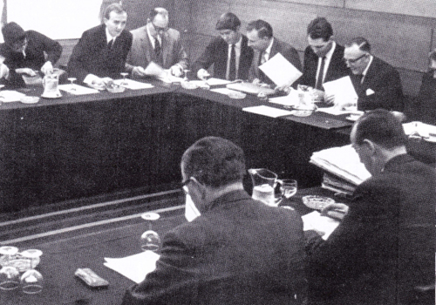
The 1968 Council Meeting. Identified from left: Russell Lowry, John Thornley, Gordon Cobban, Tom Hazlem and Ron Gammons.
Wilson McComb’s obituary for the clubs accommodated at Abingdon was short and to the point: “BMC CAR CLUBS - we have learned that the British Leyland Motor Corporation is to withdraw its support from the four BMC-sponsored motor clubs; the Austin-Healey Club, MG Car Club, Mini-Seven Club and Riley Motor Club. This means that the Car Clubs Office at Abingdon will, of necessity, be closed fairly soon'. The future of the clubs will rest with those who give so unstintingly of their leisure to organise club activities on a regional Centre basis. As to the decision, which has been taken, comment would be superfluous and serves no useful purpose. I can only offer my wholly inadequate thanks to all of you who have done so much and served these clubs so unselfishly in the past Thank you one and all.”
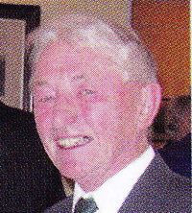Mike Hawke
Mike Allison penned this appreciation.
Mike Hawke's long association with MGs began in 1923 when he purchased a J2 when a student at the Royal Naval College at Dartmouth. He later went on to the Royal Naval Engineering College at Manadon, eventually graduating and working for the N4OD Naval Department. His work on submarine design took him to the Far East where he got involved with the local Singapore Car Club. It was here that he found the remains of a K3 which he subsequently restored. On return to the UK he was transferred to Scotland where he became involved with the Scottish Centre competing with the faithful J2. Returning home to the Bath area he was one of the first to join the newly formed Triple-M Register in 1961, becoming its popular and hardworking Secretary for 10 years. With retirement from the Navy in 1993 he took up Chairmanship of the MGCC for three years, later being elected a Vice President. He wrote a number of books; his main legacy being the definitive Club history - The First 70 Years - completed in 2000, which forms the basis of these serialised updated and enlarged Safety Fast! features. Having bravely fought cancer, Mike died in 2010 following an accident at home.

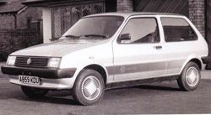

It referred to the period of time when he was out of favour with the Government of the time and for him, he was out in the cold. It is also apt for the 13 years between 1980 and 1993 during which there was no current production MG sports car, and in fact between 1980 and 1982 there was no MG car being made.
Against the background of the end of Midget and MGB production, the MG world had to endure the closure and ignominious dismantling of MG’s ancestral home at Abingdon. The well-meaning attempts of the time to continue MGB production also came to nothing and suddenly MG became just history.
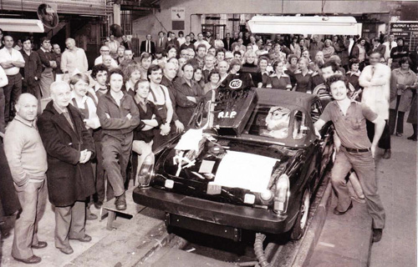
The last MG Midget heads down the Abingdon assembly line
Then just two years later, in early 1982, British Leyland’s Austin Rover Division launched to an eager, but somewhat sceptical world, the new MG Metro 1300. This immediately polarized the MG fraternity into two distinct camps. Those who simply could not, or would not, accept that this was an MG, and those who looked deeper at the new car and assessed it on its merits.
The big problem for the MG Metro, which continued with the MG Maestro and MG Montego, was the simple fact that these cars had to carry the MG mantle on their own without the support of a parallel production MG sports car. This almost certainly blighted the reception and subsequent sales, as not only MG enthusiasts questioned whether these front-wheel-drive production saloons justified the MG treatment.
A simple analysis of previous MG saloons showed that in terms of engineering changes done specifically to the MG models, the MG Metro had undergone more than many previous MG saloons. The fact that the earlier saloons have a higher level of acceptability I put down to the simple fact that there were MG sports cars produced at the same time, and that the saloons were simply regarded as there to fill a niche.
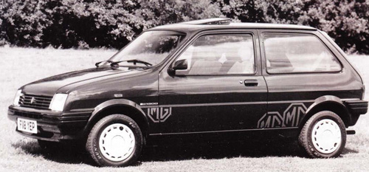
A late specification MG Metro
Motor magazine headed the first paragraph of their full road test of June 19, 1982 with, “Don’t let the so-called purists fool you. British Leyland’s new MG is an entertaining little sports saloon which is worthy of the name, and a practical and economical one into the bargain.” Now Motor were not renowned for mincing their words when it comes to road tests, and if the car was bad then they would have had no hesitation in saying so. The fact is that they didn’t and went on to end their road test with: “British Leyland have another winner here which we greatly enjoyed.”
Indeed, the car was a sales success and was joined at the 1982 Motor Show by a model that no one could claim was just a few trim bits and badges. This was of course the MG Metro Turbo, which was totally re-engineered with assistance from Lotus. This was a significantly faster car and one whose performance I had some experience of before the official launch. I was involved in some specific tyre testing and using MIRA facilities. One aspect involved driving flat out around the high-speed track with its steep banked curves. At this time, I was in a Rover 3500 SD1 reaching speeds in excess of 130mph on the straights and losing eight to nine miles per hour on the banked curves. About half a lap ahead was a matt black Metro, which I had been reliably told, was a Turbo development car. For some considerable time, we held these speeds and made no impression on the distance between this Metro and us – very impressive for the time!
British Leyland anticipated that the MG Metro would account for about 8,500 UK sales per annum; the fact that this was exceeded by a very significant margin caused a number of problems for the next new MG saloon, the MG Maestro.
The Miracle Maestro as it was dubbed was initially planned to be announced with a limited range of models. Of note was the fact that the performance versions were to be badged MG.
The sales success of the Metro caught BL by surprise, and this forced a rethink of the model line-up for the forthcoming Maestro launch. Thus, on March 1, 1983 the Maestro was launched to the world with an MG version, known as the MG Maestro 1600. The Maestro was a slight oddball from the start as it was aimed into the Escort/Astra/Golf class yet had the dimensions more common with the Sierra/Cavalier size of car. As such it did not have quite the same performance as the XRi/SRi/GTi competition.
One well-remembered feature of the new MG Maestro was the green display digital dash with is connected trip computer and voice message system. The comedians of the time had a field day with jibes about the way in which Nicolette McKenzie’s voice was nagging male drivers. In reality, the clear numerical speed display and sensible voice messages of main system faults was a boon, even if the “please fasten your seat belts” message every time you switched on the ignition was a little tiresome.
The Montego launch in April 1984 followed the previous pattern with an MG Model being available from day one and was of course the MG Montego EFi. This used a radically revised version of the 2-litre version of the O-series engine, fitted with what was then a very advanced Lucas engine management system, with microprocessor-controlled ignition and fuel injection.
Unlike the MG Metro and MG Maestro models before it, the MG Montego was aimed more up-market and in direct competition with the 1.8 litre SRi and CD Cavaliers, and 2.0 litre Sierra. It was a viable alternative to these, but still suffered from the British Leyland stigma, which of course was not helped by problems with the early MG Maestro 1600.
The MG Montego EFi carried on from the MG Maestro in having a very advanced multi-colour digital dash, trip computer and driver information system. Again, the comedians took delight in ridiculing the nagging voice, but I have fond memories of one true incident where the voice could have saved much embarrassment.
The 1984 Motor Show at the National Exhibition Centre always needs careful police planning if things aren’t going to come to a complete standstill. Manufacturers often loan out new models for police use, and to obtain exposure of the new models.
One MG Montego was being used by two very senior officers who turned the voice unit volume right down. Had they not done so; they would not have suffered the breakdown in the middle of a very busy junction outside the NEC. Messages crackled across radio channels that the engine management system had failed along with all the derogatory comments that follow. The recovery arrives, switches on the ignition and the voice says, “The fuel level is low”! One can of petrol later and the car is up and running. The cartoons that appeared all over the place for weeks afterwards tell the rest of the story!
The Montego EFi was a competent saloon in its class but did not particularly stand out from the crowd. However, on April 3, 1985, arrived an MG Montego that most certainly did. This was of course the MG Montego Turbo, which literally burst onto the scene with performance previously unheard of in this class. The development of the 2-litre O-series engine followed similar lines to the MG Metro Turbo, with the use of a specially prepared sealed SU carburettor. Unlike the Metro, there were no serious transmission weaknesses and so the turbocharger fitting included an intercooler, which allowed the engine to produce a market-leading 152bhp with an equally impressive 169ft lbs. of torque. By comparison, the Saab Turbo was the accepted turbo road car of the period with 145bhp and more weight to move.
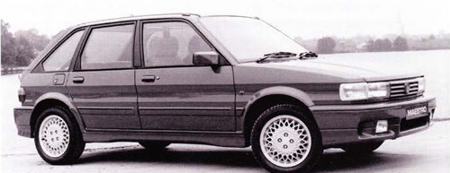The Maestro Turbo
Quietly and with no fanfare, on a corner of the Austin Rover stand at the 1988 Motor Show at the NEC, was sitting a flame red MG Maestro with an aggressive body kit and Turbo badges. Here at last was the final piece of the jigsaw with a production MG Maestro Turbo. The phrase “better late than never” was muttered in many quarters and is quite true. On the positive side the delay had seen the need to involve Tickfords in the development and build. This led to the striking body kit, the use of the intercooled O-series straight out of the Montego Turbo, and the 1989 introduction 15-inch wheels and imperial sized ultra-low-profile performance tyres.
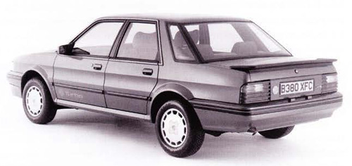The Montego Turbo
The MG Maestro Turbo became the pinnacle of the modern front-wheel-drive MG scene. It took the mantle of fastest production MG from the Montego Turbo, but later relinquished it to the MG RV8. It provided performance that completely trounced the market competition of the period and forced many a Maestro-baiting motoring journalist to eat humble pie. Road tests, although few, indicated that the cars were faster than the claimed performance, in that well under seven seconds was average to get to 60mph and a top speed of 130mph was easily achieved.
Whilst the production MGs were rolling from the production lines during the mid-1980s, Austin Rover decided to take a foray into international Group B rallying. In doing so they created one of the most famous MGs of all time, the MG Metro 6R4. This was a very unusual car not least for the decision to use a naturally aspirated three-litre V6 engine, rather than follow all the other major manufacturers with forced induction. It was just the beginning to develop its potential when the powers that be decided that this class was too powerful, and they consequently banned it. This led to the 200 production and 20 evolution models of the car being sold to private owners to use mostly in other classes of rallying. Will Gollop with his championship-winning 700-plus bhp rallycross version demonstrated the potential of the car.
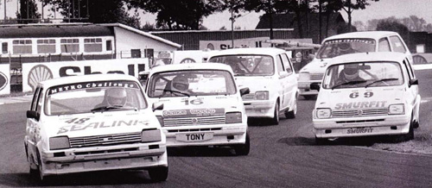
The Metro Challenge, a popular series in the 1980s dedicated to the MG Metro Turbo
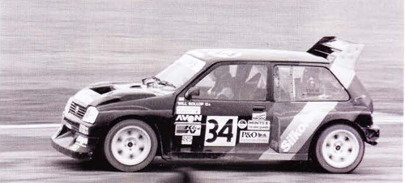
Will Gollop in his MG Metro 6R4
At the completely opposite end of the scale is the quite long-standing situation with value of FWD models. Apart from the Turbos, the FWD MGs have never really generated a wide and lasting enthusiast base. Generally, there is a period of high enthusiasm, which then wanes, before another car takes its place.
The second-hand values of the cars became very depressed and the result was the rapid disappearance of the cars from daily use on our roads.
The one benefit of these rock-bottom residuals was that it allowed new young drivers the opportunity to own an MG. The clear lack of status meant that young MG FWD owners had a difficult enough time justifying their choice with their peers, then to find they were not accepted by MG people really put them out in the cold. History has shown that this opportunity was not grasped properly by the Club and some members went out of their way to actually alienate these poor lads and lasses. The formation of alternative clubs such as the MGM Group was one result of that. How much of a loss to the MG Car Club is impossible to assess, but a loss there certainly has been. I wonder whether we, the membership of the Club, will learn from this? I doubt it, as human activity shows the same mistakes being constantly repeated, but at least we should try.
Even so, the MG Car Club clearly embraced the FWD MGs, and still does, even if too many individuals within the Club did/do not. In the early 1908s dedicated enthusiasts of the MG Metro started Metro file Safety Fast! passing on all sorts of useful information for the growing number of owners in the MG Car Club. In fact new owners of the FWD MGs helped to increase Club membership, and we must also remember that the 1908s was the period when the hot hatch was king, and no volume manufacturer paid more than lip service to soft top sports cars. Once the MG Maestro and MG Montego were established, the Front Wheel Drive Register was born. This Register has always had a core of dedicated enthusiasts helping to support other owners. The biggest problem is that there were few enthusiast members who only own an FWD MG. The majority of MG Car Club FWD owners will also own another MG two-seater sports car and this tends to take the limelight.
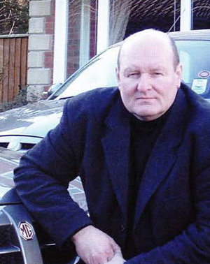
Roger Parkers’s attraction with MGs goes back to a boy in the early 1960s with older siblings owning MGs and culminating with him being able to convince his mother to buy an MG1300 in 1970 instead of a Morris, and benefitting from regularly driving it and later tuning it! He became a police officer in the Midlands in 1971 and had a very focused career in traffic-orientated matters, which included the development of the first UK unmarked police patrol cars with fully integrated video in the late 1980s and then the further development of this with Automatic Number Place Recognition (ANPR) with the first fully mobile system in the UK that saw him drawn onto a national ACPO (Association of Chief Police Officers) working party for the national introduction of ANPR technology. Roger retired from the police in 2001 when he took up a position with the MG Owners Club to provide members with technical advice, writing magazine features and general Club activities. Roger has owned his 1968 MGB since 1973, which he still has in a much-modified form and he and the car were pivotal in convincing the Rover management to progress with the Adder project, which became the MG RV8.

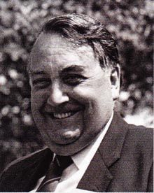
In writing this chapter in the Club's history, spanning the years away from Abingdon, I am greatly indebted to the late Martin Brent who, while working for Wilson McComb in the Club Office at MG, was intimately involved with the expulsion of the MG Car Club from the factory; Peter and Christine Tipton who managed the Club from Boston for nearly four years; Peter Browning, so closely involved with our sister club, Austin-Healey at the time and, of course, Bill Wallis, our President whose records and personal recollections span over forty years of the Club's 70-year life.
The reverse takeover of BMC by Lord Stokes' Triumph and Leyland empire signalled the warning that matters BMC would be subjugated and thus it was, when in 1968 the axe fell on the four factory clubs operating out of Abingdon: the Austin-Healey Club, the Mini 7 Club, the Riley Motor Club and the MG Car Club. Safety Fast! was to cease and a new Leyland magazine called High Road was to take its place. Even the now legendary Wilson McComb, the first editor of Safety Fast! and subsequently general secretary of the MG Car Club was powerless to halt the changes.
At this stage feverish discussions were taking place between Martin Brent, Wilson McComb, and John Thornley, the first two named doubtless pondering their future careers, while John Thornley, manager of the MG factory at Abingdon, was far from well, his condition probably not aided by the politics of the new British Leyland. However, John had had earnest discussions with Gordon Cobban, then the chairman of the Club's South East Centre, a club man through and through, and in the view of Martin Brent and others, the 'white knight' at a time when the Club was threatened with extinction.
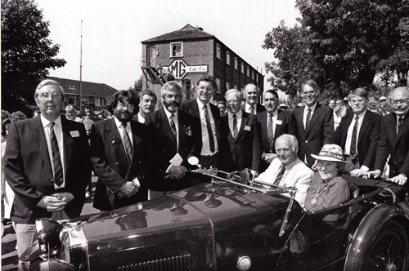
The directors of MGCC with Lord Montague and Jean Kimber Cook seated in the MG
It was Gordon who perceived the need to enlist the help of Martin, in the absence of Margaret O'Brien (about whom more in a moment), in re-establishing the Club in Abingdon away from the factory. In offices over a bank in the town's Market Place, assisted by two secretaries, Martin took over the editorship of Safety Fast! at the end of 1968. It was at this time that Margret O'Brien came into prominence. Margret had been a long-serving key administrator dealing with membership for the MG Car Club in its time at the factory. Following a spell in hospital, Margret returned to the MG Car Club in its new offices while Martin Brent (and one of the other secretaries) returned to the factory. Margret ran the office with Teutonic efficiency, she was after all German by birth, and was held in high regard. However, as history was to repeat itself years later the Club's finances could not sustain the cost of the lease and the first Abingdon era, started in 1930, ended 42 years later in 1972. The Club was to be almost another 20 years in exile.
Throughout the period above the bank, Gordon Cobban had made regular visits from his home in Essex, often with his wife Elsie, and it was therefore inevitable that most of the Club’s administration would end up on the other side of London, at Gordon’s home at Ilford. It is probably true to say that it was Gordon's administrative skills, energy, and wholehearted commitment to the Club, often involving paying bills on behalf of the Club out of his own pocket, which maintained the Club structure. The only dark cloud in the closure of Market Place was the fact that archive material, particularly of competition history, which had been rescued from the factory, and stored in the back room above the bank, went missing at this time. Unfortunately, Gordon was not so interested in the tip, which the back-room archive store had become! Ultimately, at the end of the lease, most of the remaining material was taken to Syd Beer's garage at Houghton in Cambridgeshire for safekeeping. Margret O'Brien, however, continued to maintain the Club membership administration until she retired in 1976 when this function was moved to Houghton under Rhubean Warwick.
Thus, throughout most of the 70s, Gordon and Elsie maintained the status quo with membership at modest levels and finances tight. However, in August 1978 Gordon, Piers Hubbard and Anthony Littlejohn were entrusted by John Thornley to set up a Club Office.
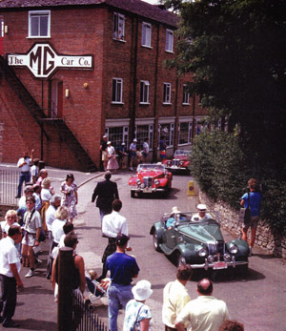
New England T Register parade past the administration building
Sheila Laurence of the Lincolnshire Centre was appointed assistant to the general secretary (Gordon) and by December of that year the Club had established itself in Boston. John Thornley, however, was still unhappy, even frustrated, that the Club was not running harmoniously. As a consequence, in November 1979 he established a small group which came to be known as the Think Tank.
One of the members of this Think Tank was Peter Tipton who in June 1980, aided by his wife Christine, was appointed general secretary in succession to Gordon Cobban on a part-time basis following an advertisement in Safety Fast! of necessity this became full-time in January 1981. With a professional marketing man-and-wife team at the helm, the support of the Lincolnshire Centre and with the lease of premises at 67 Wide Bargate, Boston, the Club began to have some structure once more. The one function that was not maintained at Boston was regalia sales which for two years, 1981-2, were managed by June Wallis from her home at Solihull.
However, by 1983 with Club membership still at a low level and magazine production costs high, the Club's finances had become perilous. Safety Fast! had been reduced to a bi-monthly publication, complaints from members were rife and South East Centre had presented a charter for the establishment of an elected management committee/board of directors to manage the Club on an ongoing basis, rather than the twice yearly council meetings which were clearly cumbersome and ineffective. For day-to-day management yet another working party was established to take a hard look at all aspects of the Club's operation. At the same time, in November 1983, the lease of the Boston premises at 67 Wide Bargate was up for renewal. The Club's solicitor, Rob lnnes-Ker, cautioned against entering into a further five-year lease while so much uncertainty existed. The knock-on effect of this indecision would impact upon the renewal of contract terms with Peter and Christine Tipton. This ultimately led to formal termination of the business relationship at the end of January 1984, although Christine kept matters ticking over for another nine months.
Running parallel with this were several investigations into alternative accommodation. Among the various properties that the then-Chairman Bill Wallis, who had succeeded John Thornley in 1980, and I looked into were a Euro grain store in Banbury, a derelict Morland's pub in Abingdon town centre, and even the administration office attached to the old MG Car Company A block assembly building. Morland's Brewery was, as ever, helpful, but discussions with the Austin Morris division of British Leyland elicited the fact that there was space galore at the Austin Morris Training Centre at Studley in Warwickshire. Tempting possibilities of the Club being situated in the beautiful, but as yet unrestored, coach house in the grounds was a motivator but, clearly, temporary accommodation was necessary until the coach house was restored, which in the event it never was.
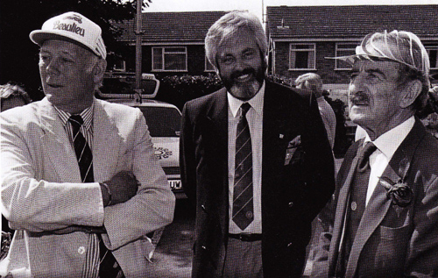
L-R Lord Montague, Will Corry and Douglas Mickle
In the end after considering other properties in the grounds and in the nearby town of Studley, the Club was offered the opportunity to set up a Portakabin, with Anders Clausager, the legendary Archivist of British Motor Heritage (whose home Studley then was) as neighbour; in another Portakabin. Shortly after, a second Portakabin was acquired in which to store regalia.
On December 1 1984, Boston was vacated and the Club's goods and chattels made their way by van to Studley Castle under the direction of the ever-active Bill Wallis, who had arranged for the address to be PO Box 251, Studley, harking back to the factory telephone and car production start numbers. A new Club administrator, Pat Stout, was appointed and on April 12, 1985, the Club office was officially opened. The Studley temporary Portakabins were to be our home for another four years before the next move, again temporary, which was at least in the right direction, to Radley, some three miles away from the Abingdon factory site. By mid-1987 paid home membership was in excess of 7,800. Workload pressure was increasing for the three staff and the need to determine a long-term home for the Club was clearly becoming more pressing. In August 1987, I scribbled the first plans as to how we might raise £100,000 for an office somewhere….
A month later we received details of a modest residential property at 150 Ock Street, Abingdon, as a result of some research by Geoff Radford (then of the Vintage Register), an estate agent himself, and Chairman Ron Gammons, (who had succeeded Bill Wallis in 1985). After some misgivings, the directors of the Club marginally voted in favour of purchase. Thus, the position was polarizing, Studley versus Abingdon and Council in October 1987 gave the directors authority to “get on with it” and decide.
However, by complete coincidence, within days of the October Council meeting Austin Rover, as they had become, offered us the lease of a semi-detached house, known as Rookery Cottages, in the grounds at Studley. But on November 25,1987, at a board meeting at Studley the decision was taken to go for Ock Street.
It was after this meeting that trouble started. Vice Chairman, Steve Dear, was strongly of the view that we should take up Austin Rover’s offer of the Studley house in the short term, a view strongly supported by Club President, John Thornley. Steve Dear resigned and John Thornley wrote a scathing letter to the chairman, commenting that when the Club does move back to Abingdon, it is desirable that it should do so with “some sense of style”, rather than “move into a sleazy oasis in this prospering town”. My own position, in a letter to Steve Dear urging him not to resign, was that we could not continue to operate out of Portakabins. “Ock Street is a start and it is Abingdon”. The president’s letter of December 7, 1987, to the chairman sadly saw their relationship at an all-time low, surpassing differences of opinion earlier in the year. Matters came to a head on December 14, 1987, when Vice President Jack Armstrong, on behalf of John Thornley (who was having a cardiac monitor fitted), and past Chairman Bill Wallis attended a special meeting of the directors at St John’s Hotel, Solihull. On the line was John Thornley's continued presidency if the Club persisted with the Ock Street project. After much reasoned debate four decisions were arrived at: (1) Formal building fund to be launched, details to follow; (2) We would proceed with the temporary lease on the Studley property; (3) That a general secretary would be appointed (club membership was now 8,500) and this was an interdependent requirement; (4) That a property of our own in Studley or Abingdon areas would be sought.
The next day solicitors were instructed to withdraw from the Club’s proposed purchase of Ock Street. One dissenter from this last position was Bill Wallis who felt that the Board had taken an incorrect decision, but that it had had no option in the light of the facts put before it. Upon the outcome of the meeting Steve Dear, who was present, withdrew his resignation, which was happily agreed. However, Steve was still unhappy over a number of issues and continued to press for the Chairman to stand down. In the event it was Steve who left at the end of January 1988. Ironically at the March 19BB board meeting the directors decided that the lease on Rookery Cottages, Studley, could not be taken up because of certain conditions required by Rover Group and the limited two-year planning permission granted by the local council. At that same meeting it was resolved that a new bank account for a Building Fund be set up. At Council on April 16, 1988, the Building Appeal was formally launched and well received, with myself as director of the Building Appeal. The battle was on, property prices had been rising while we procrastinated, and time was of the essence. Ron Gammons was re-elected chairman at the October 1988 council for a fourth term, but a year later was succeeded by Will Corry by which time our fifth and penultimate move to Radley had taken place.
During the summer of 1988 fundraising began in earnest. Contributions were received from all over the world, making one feel very privileged to be in the centre of the Club at such an emotional time. In July the chairman and I met with numerous civic dignitaries in the Abingdon area, the Vale of the White Horse District Council, Thames and Chiltern Tourist Board, the local Mayor John Patten, the Curator of Abingdon Museum, the Managing Director of Pavlova Leather Co., Standard Life Assurance Company (who had purchased the factory site) and others.
A proposal was put to the Vale of the White Horse District Council for their support in developing one of a short list of four sites, including, if a greenfield site, a design for a combined museum and administration office. However more realistically, our excitement was increasing as we were becoming aware of the plans of Pavlova Leather who, it should be remembered, had sold the factory site to MG Car Company in 1929 almost 60 years before!
Thus, on Tuesday August 30 1988 an extraordinary meeting of the directors was held at the Great Northern Hotel, Kings Cross, London. The purpose was simple. Premises owned by Pavlova Leather Company adjacent to the MG Car Company's former administration block (now Larkhill House) had come on the market as a development site for eight flats. No. 11, the smallest semi-detached property, was still occupied by Geoff Blanch, a Pavlova employee, and his wife Rene; No. 12 was unoccupied, damp and in generally poor condition, but with considerable potential.
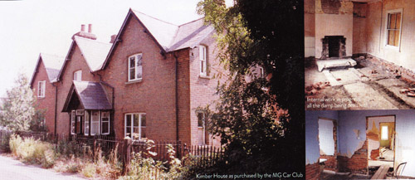Kimber House as purchased by the MG Car Club
Chairman Ron Gammons had taken advice, in particular from Club member and architect Alan Paine from Lowestoft. Alan subsequently had to commute between the East Coast and Abingdon many times before the day was out. After survey, Alan was of the view that £175,000 was a reasonable offer for the entire site. The chairman and I had also sought the opinion of the President, John Thornley, who told us to "go for it" on the basis that the site value for flat development provided a very good fallback position if we failed to achieve our goal, since the restoration costs were estimated at another £75,000!
At that Kings Cross meeting the board considered, and rejected, the three other possible sites in Abingdon and the way forward was clear. The Chairman proposed, and I seconded, that we proceed with our offer and seek planning approval for change of use. The board was unanimously in favour. Two further board meetings took place in September; the second of which, on 27th, was specially convened to discuss an unexpected letter received from the president requiring Ron Gammon's resignation following a number of differences of opinion. Vice President Bill Wallis was present. After a debate lasting over an hour, the directors felt that Ron, in the interests of Club harmony, should not stand for re-election the following month. At that same meeting, I reported that the Building Fund had exceeded £30,000, and the chairman reported that an "elder statesman" of the Club was, in broad terms, amenable to the granting of a six-figure loan for the fund. An eventful meeting!
In the event, Ron was re-elected for one last year which was considered to be in the best interests of the Club and, importantly, the Building Appeal at that time, before Will Corry succeeded him at the November 1989 AGM. Fund raising continued unabated at national and local level. The lottery raised £12,000 in 19BB (with a winning prize to the Monaco Grand Prix). The first reprint of a Gordon Crosby painting owned by John Thornley of the MG 18/100 Tigress at Brooklands in 1930 was launched that year with copies signed by John Thornley at £50, unsigned £25, and this was followed by Bryan De Grineau's painting of the MG K3 driven by Count Johnny Lurani in the 1933 Mille Miglia. Count Johnny Lurani and his wife were guests of honour at Silverstone on May 27-28, 1989 and, again, freshly signed prints were eagerly snapped up at £50.
The 1989 lottery, which raised another £7,000, featured a flight on Concorde for two people as first prize. Three auctions of automobilia and parts were held at Silverstone. A run of 750 Royal Doulton plates showing M-types leaving the factory down Cemetery Road was commissioned, selling at £28 each. We had loads of wall clocks from Germany, limited edition commemorative watches from Switzerland and numerous other items from tee shirts to Christmas cards. But equally important was the money collected at Natters and local events in Building Appeal Buckets, the initiative of Dennis (The Bucket) Ogborn, or sponsored events, too many to recall, not only around the United Kingdom, but throughout the world. To mention individuals by name would be invidious and incomplete but amounts of a few pounds to several hundred steadily flowed into Club Office throughout the campaign.
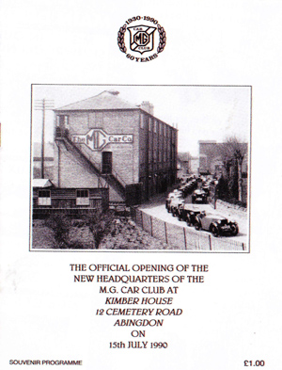
The official opening programmes
However, back to Abingdon. Ten months of protracted negotiations and the Club successfully concluded the purchase of 11/12 Cemetery Road at a price of £180,000. The campaign had, by then, raised an excellent £65,730 in the first 14 months. In addition, the benefactor who was to lend us the £100,000 interest-free was Douglas Mickel, a long-standing stalwart of the Scottish Centre, without whom the project could well have foundered. Douglas has since magnanimously gifted this money to the Club, thereby freeing it from what would have been a significant ongoing repayment of capital over 10 years. The balance of £15,000 to acquire the site came from Club funds. Phase l was over. Phase II, the clearance of the site, refurbishment and upgrading of the buildings was just about to begin, but another £75,000 was still required.
While all this excitement over the purchase was going on in the summer of 1989, the Club was fortunate enough to take a lease on office premises at J.C. Curtis & Son, Haulage Contractors and Quarry Operators, at Radley. Not only was the Club psychologically and physically now already back in Abingdon, it also meant we were on the spot while building works continued under Alan Paine, assisted by Michael Cannon, the deputy Club administrator in Club office. Thus Phase II, The Diamond Jubilee Building Appeal, was launched with a new brochure, this time depicting a real building which the Club owned. Site clearance began on November 13, 1989 and a number of members kindly donated their time or provided building materials free, or at cost, to help the project along. As the one-year lease at Radley was up in June 1990, the target date for our staff to move into Cemetery Road was set!
Funds continued to come in during 1990 although slower than before. Building work was not held up and the great opening day came on July 15, 1990, when Lord Montagu of Beaulieu formally opened the Club offices in front of a large crowd of Club members from around the world. They witnessed a very emotional occasion. By the end of 1990, with another successful raffle yielding £7,000, the deficit to clear the refurbishment costs was down to £14,500. In 1991, after a third successful Silverstone, the deficit was a mere £3,082 and the battle was effectively won.
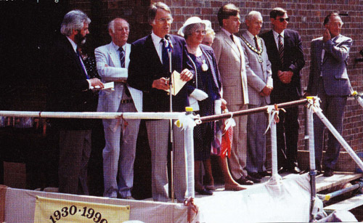Ron Gammons at the official opening of Kimber House
Income continued to trickle in right through the 1990s as the balance of prints and plates was finally exhausted and members' standing orders ran their course.
Finally, tribute must be given to the team that supported me throughout the campaign: Jon Moore (who ably organised the annual lottery), Phil Jennings, Dennis Ogborn, Christine Poxon, Peter Mace, Simon Farthorpe, our Silverstone Auctioneers, Glynn Guisti and Geoff Radford, and Club office staff led by Club Administrator Marilyn Moule and later Lyn Jeffrey plus others too numerous to mention in Centres and Registers around the country and overseas.
With the support of Club members and well-wishers worldwide, the campaign raised a staggering figure of just under £150,000.
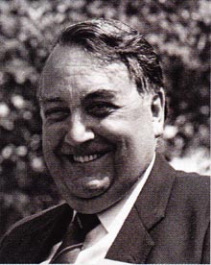Peter Best was brought up in Hendon, north London, but later moved to Hove in Sussex when he joined the Merchant Navy and later joined a shipping line. He joined the Ford Motor Company in 1961 working in marketing and sales traveling the world extensively. He later moved to Volvo where insurance was part of his responsibilities which led to the formation of his insurance company founded with his wife Marian in 1985. Today Peter Best Insurance Services is a strong specialist insurance broker with particular interest in classic cars and including MG. Peter joined the MGCC in 1974 and was Chairman from 2005-2007 playing a major role in the Kimber House Appeal Fund.
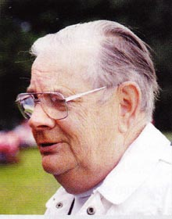
Syd Beer was an analytical chemist by profession and his love of motor cars started when he enjoyed time in his father's garage and developed a passion for classic cars. This led him to start a collection of MGs at his village garage in Houghton near St Ives in Cambridgeshire. Amongst the famous cars he owned was the ex Kaye Don K3 single seater, ex Harvey Nobile Q Type and ex Norman Blck NE. Syd formed a close friendship with John Thornley which led to his acquiring the pair of Jacobs Midgets and the most successful ex works MGB. When the Club found itself without a home in the British Leyland era, Syd offered premises at Houghton for two years.

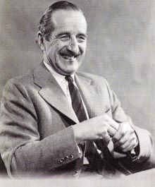
At the official opening of Kimber House on July 15, 1990 congratulations and backslapping was the order of the day.
The objective of having our own headquarters in Abingdon had been achieved and, even better these were near the exit gate of the old factory through which successive MG models had gone on test or been delivered to proud new owners. We were blissfully unaware, however, that in the near future the board of directors would embark on ambitious projects which would almost put the Club on the rocks financially during 1992.
The result of this very near miss focused many people on the position of Kimber House. If the Club had foundered, Kimber House would have to be sold to pay off creditors. This would have not only been a major disaster but also a breach of faith with the many, and Douglas Mickel in particular, who had given so generously.
It was decided that the asset of Kimber House should be placed in trust as soon as the Club's finances would allow. The process of forming the Trust moved along slowly in line with the gradual improvement of the Club's finances, but finally the proposal to put Kimber House into trust was debated at the council meeting on March 30, 1996. In the meantime, several names of trustees designate had been put forward and the board were overwhelmingly in favour of it being named the Douglas Mickel Trust. Douglas and Marjorie were thrilled.
The first meeting of the trustees designate was held on March 17, 1995 when it was resolved to seek charitable status from the Charity Commissioners. In the event this was not obtained, the Charity Commissioners reasoning that "a purpose is not charitable if it is mainly for the benefit of specific individuals". The aims and objectives of the Trust were however debated at length, tested at council meetings, and agreed as follows:
1. To own and manage the freehold of Kimber House and adjoining property.
2. To maintain and preserve trophies and other historic material and archives of the MG Car Club
3. To encourage and assist research into the history of the MG Car Club and the archive material
4. To encourage the Club to hold seminars on maintenance/restoration of MG models.
The Trust was up, but not running by March 29, 1996, endowed by Douglas Mickel who generously wrote a cheque equal to the sum MG Car Club had remitted as the first, and only, repayment of the original loan back in 1990; the loan to the Club having been commuted to a gift on March 6, 1996. It was not until 1997 that Kimber House and the semi-detached dwelling next door were finally gifted to the Trust.
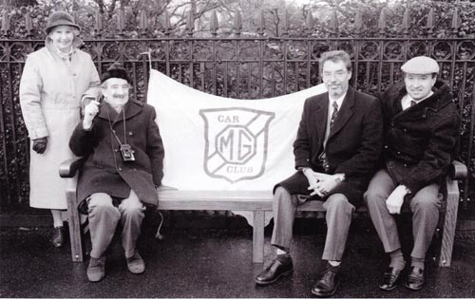
Gathering of the Scottish Ctr senior members (L-R) Betty Herald, Douglas Mickel, Bruce Herald, Ewan Murry
The Trust could not have better tenants; they looked after the property as if it were their own! It has been particularly gratifying that the Club in 1999 found sufficient resources to relocate the former tenants from next door, renovate the property to provide additional accommodation for Club purposes, and still have money in the bank.
The Trustees are also delighted that their first project is to contribute to the cost of gathering articles worldwide for this book.
The original Trustees were: Tom Gray Chairman (Scottish Centre), Robert lnnes-Ker Secretary and Treasurer (Abingdon Works Centre), Victor Smith (South East Centre), Paul Brazier Secretary (North West Centre), and Douglas Mickel, OBE 1911-2000.
Douglas was introduced to the MG marque by his uncle Robert, who campaigned in a TA. His proudest MG memory was being presented with his first ever award by Mrs Cecil Kimber, who travelled north with her husband to Taymouth Castle for an MG (Scottish Centre) Weekend Rally on May 20-21, 1939 (Third in saloon class, C type Ford!). Douglas had joined the MG Car Club as an associate member shortly before the rally and later was to become, from 1948, secretary of the Scottish Centre for a period of 43 years! But Douglas never owned an MG until he bought one of the last Midgets in 1980. An MG Metro and two MG Maestros followed. His son, Bruce, still has a TD, which his parents gave to him on his 21st birthday. Douglas may not have owned many MGs but somehow the Club was in his lifeblood.
THE FUTURE OF THE DOUGLAS MICKEL TRUST - BILL SILCOCK
At the start of 2013, the MGCC Board of Directors set out to document the relationship between the Club and the Douglas Mickel Trust (DMT), in order to place this on record for future Board members as an easily understandable reference guide. To aid this, the Board called forward all the papers held by the Club's previous solicitors. After an initial analysis of the documents there appeared to be some gaps in the information available, so the Board asked the current trustees for their help in understanding the position.
After a short time, the Trustees, led by Geoff St John-Mitchell, agreed that there were some inconsistencies in the documentation held by each side, and the Club and the Trust decided independently that legal advice was required. The Club and the Trust instructed separate solicitors, and both legal advisors agreed inconsistencies existed, and gave it as their opinion that Barrister's opinion should be sought in order finally to clarify matters.
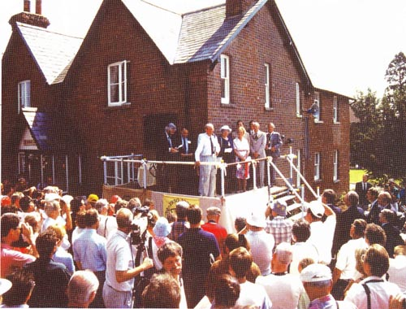
The official opening of Kimber House in 1990

At the MGCC Council in March 2014 the Club Chairman, Bill Silcock made the following statement:
"The Douglas Mickel Trust was set up in 1994 to put Kimber House beyond the reach of any Club creditor in the event of a financial disaster befalling the Club. In recent times it has become apparent that the Trust was not set up as well as it might have been. The Club and the trustees have independently taken legal advice, and a way forward is being mutually sought. In the worst case, the ownership of Kimber House will revert to the Club and a new trust will need to be established. Kimber House would then be put under the ownership of the new Trust to provide continued protection for the Club."
The Trust then received Barrister's opinion resolving the situation. This supported the solicitors' fears that the DMT was not a valid trust in law and had therefore never existed in law. It should be emphasised that the original trustees acted in the light of their advice at the time of the formation of the trust, and no blame attaches to them for this conclusion.
After considering Barrister's opinion, the DMT trustees asked to hand back all the assets of the DMT to the MGCC, and a meeting was convened between the trustees, the Club Chairman Bill Silcock, and the Treasurer Richard Colston on May 14, 2014. At this meeting, all the DMT documentation and accounts were lodged with MGCC, and the financial assets of the Trust were handed over to the Club. These assets were deposited in a standalone account until the Council approved a proposal for their use.
The title to Kimber House was initially left with the four named individuals (all respected MGCC members) who had previously held the property on behalf of the Trust. This was to continue until the Club had taken legal and accountant's advice as to the position relating to stamp duty liability arising from the transfer of the ownership of Kimber House. The Club received assurances that no stamp duty was payable, and the Club's solicitors transferred the title in Kimber House back to the MGCC
The Board then took legal advice on the best way to protect Kimber House from any future risks. Its solicitors, Morgan Cole, advised that another Trust or a separate company were inappropriate ways to protect Kimber House, and the recommended way forward was for the Club to have robust management procedures. Our then current Memorandum of Incorporation and Articles of Association, together with the Club Rules, were passed to Morgan Cole to get their recommendation on the amendments necessary.
A sub-committee of the Board was created led by Bill Silcock, with the very able support of Richard Colston, Dick Morbey, Chris Hunt-Cook, and Jim Andrews. Their remit was to review and re-draft the Memorandum of Incorporation and Articles of Association, together with the Club Rules, in line with Morgan Cole's recommendations.
It was concluded that the Memorandum of Incorporation need not change, and was an historic document in its own right, and the team concentrated their efforts on the Articles of Association and the Club Rules
Drafts of the revised documents were then circulated and approved by all the CRBs, and an Extraordinary General Meeting was called to coincide with the next Council meeting in March 2015, when the final revised documents were unanimously adopted.
The Douglas Mickel Fund was established during 2014 to continue some of the objectives set out for the previous Trust.
Its structure and procedures were developed by a small working party made up of lan Lindley (then Chair of the Caledonian Centre), Phil Jukes (then Chair of the 6.3.5 Register), and George Wilder, MGCC Director. Their report was accepted by the Executive Committee and put into place so the Fund could operate in 2015.
The Fund’s objectives are to support activities, which are:
• securing the long-term future of the MGCC
• developing the MGCC Archive and records
• developing the knowledge about MG
• developing and enhancing the skills of young people to work on older vehicles
• other meaningful projects that support and enhance the use of MG cars.
All MGCC Members are eligible to apply to the DMF for assistance whether individually, as a collective, or as a Centre, Register or Branch. The DMF Panel has the option to provide both 'loans' and 'grants' to applicants, depending on successful consideration of any application. However, in all cases the application must fall within the objectives of the DMF.
The DMF Panel is made up of three MG Car Club members, one each of Director; Register Chairman and Centre Chairman and they are elected from suggestions made at Board level. This will be on a rotational role so that no one individual continues for more than three consecutive years. The DMF Panel will report to the Executive Committee on its activities through the nominated Director at regular intervals.
The Fund’s first supporting project was to help the SVW Register build an engine stand for the Club’s display VA engine. The cost was split between the Register and the Fund. The engine and stand are now on display in the new Bill Wallis Archive at Kimber House.
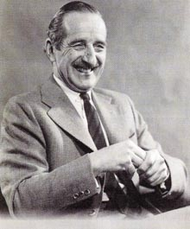
Douglas Mickel was born in 1911 in Cardross in Scotland, educated at Glasgow University and joined the family building company. Moved to Edinburgh to open a new branch of the company later becoming its Chairman. For services to the building industry he received the OBE. His wife Margery received the MBE for services to politics. Prior to World War II Douglas joined the MG Car Club but he did not have an MG and campaigned a Ford saloon. In the War he joined the Royal Engineers and attained the rank of Captain. After the War he joined various local business associations where he served with distinction. In motorsport he became a leading light in the Scottish Sports Car Club and the Royal Scottish Automobile Club. He re-joined the MG Car Club and was to serve as the ever-enthusiastic Secretary for the Scottish Centre for 43 years. Douglas only gave up skiing and badminton at the age of 80 and maintained a keen interest in the Scottish Centre and the club until his death in 2000.

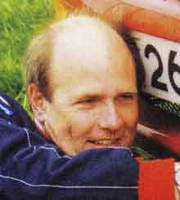
Although the MGF has provided the single largest boost to Club membership in the period since September 1995, this has not occurred without planning and foresight. Having had a significant input to the formation of the MGF Register, I was fairly sure that the minutes of the council meetings of 1994 would provide the proof of our collective thought processes.
Sure enough, in the minutes of the April 1994 council meeting, Don Bishop of the MGB Register proposed that an embryonic register be formed to accommodate the then much talked about PR3 model being developed in what was then Rover Group, which in the previous month had become part of the BMW Group following their purchase of the company from British Aerospace.
I was then an area manager for that company, looking after the commercial relationship between ourselves and the UK Rover dealer network and had already seen and sat in a prototype at the Canley styling and design centre. I was later working at the Rover Group facility, Studley Castle, where the Club was housed in the late 1980s. It was a short walk to the Portakabin where it was managed, I was therefore in a unique position, knowing the truth but unable to say a word about it in the meeting!
Other than agreeing Don's proposal, nothing more happened until the full council meeting of November 1994, when during "matters arising" there was much talk about how we should progress this opportunity. One idea was that we should ask Rover Group to place a membership application card in the handbook pack of each vehicle leaving the factory. At this point, I could contain myself no longer and decided to offer some advice.
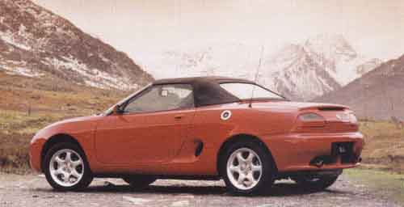
1995 press photo of a 1.8i MGF
It became apparent to all listening that I knew more than I was prepared to reveal and during the lunch break, Victor Smith engaged me in conversation about a vacancy on the board of directors and the opportunity for Rover to have input at board level through myself. The new car was still unconfirmed in spite of all the preparations and I resolutely refused to confirm it and the motions for debate records the following: "That provision be made, in advance, to ensure that should a new MG car be announced, the MG Car Club is ready to provide a service to purchasers of the new car".
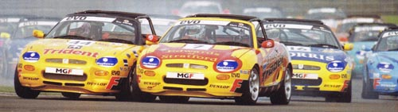
MGF Racing was fast and furious
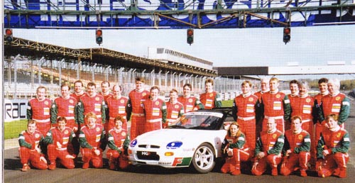
The MGF Cup Championship race drivers
The Club had clearly started to think about what this product would produce in terms of extra membership and was making available a Register even before launch. Perhaps it should also have done this upon the launch of the MGB; what would that have done to membership then, I wonder?
That afternoon at the AGM, I was voted on to the board. My responsibilities became those of the Centres, Registers and Branches of the Club, which gave me the opportunity to steer the initial fortunes of the PR3 Register.
Interestingly, the media and Club members had assumed that it would be called the MGD and it was often referred to as that at board and council meetings until March 7, 1995, when the car was finally revealed at the Geneva Motor Show. Indeed, many entrepreneurs had rung the MG and Rover offices offering to sell us MGD registrations that they had reserved with the DVLA, hoping for a quick profit. It was difficult not to give the game away. Whatever happened to all those number plates?
At the January 1995 board meeting, I revealed that I now worked for a division of the Company called MG Cars, as a regional manager. (Having seen the vacancies available in this division during October 1994, I thought how appropriate it would be, both as an enthusiast and as a board member to work in this part of the company.)
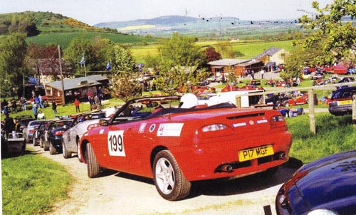Abingdon Trophy cars line up at Prescott in 1998
I was given permission to reveal the outline product details but not the name. I asked for secrecy to be observed and the minutes of the meeting do not record any details of this presentation. Subsequently, plans were laid to celebrate the new sports car's arrival by an MG Car Club run to Geneva, to coincide with the launch, in cars representing the history of the marque. This was organised by the then Overseas Director, Alan Kingwell, who also provided support to the run with Bob Marshall, in a Land Rover provided by Rover Group This event was also filmed by the BBC for the subsequent series "When Rover met BMW" although it was edited out of the final programmes to make way for the more interesting story of John Towers' imminent departure as Rover chief following disagreements with the BMW board. All rather poetic when you consider six years further on, John Towers as the head of the Phoenix Consortium, buys back Rover from BMW for the princely sum £10, announcing this staggering situation to the world's Press on May 9, 2000.
The initial meeting of the MGF Register was held immediately after the Council meeting at the Upper Reaches Hotel in Abingdon in April 1996, and it was attended by four people: Dr Rob Higgins, myself, already an owner with a company-provided MGF, Dawn-Marie Turner (subsequently to become my wife) and Nick Cox, who was about to order his car. It had been decided to leave the fortunes of the PR3 Register in the hands of Don Bishop until deliveries of the vehicles had started. Don had issued the first 20 or so membership cards by the time he came to hand the reins to the first chairman of the group, Julia Marshall (also a board director at that time). She was able to take delivery of her car a few days after the launch from the showrooms of Clive Sutton in Old Brompton Road, Kensington. She was to receive a splash of publicity in the Daily Telegraph, following their headlines a week or so earlier asserting that the average customer was male and in his middle fifties. Here was a twenty-something blonde female disproving that theory and getting a half-page of full colour coverage in the process; not for nothing, she was the director responsible for the Club’s publicity.
This was an excellent start for the Register since Julia had mercilessly promoted the MG Car Club in the article and its support of the product through her involvement in MGF activities. Coupled with this was the support of the MG Cars department at Longbridge who had instituted an advisory "best practice" policy for its dealers to offer membership of the Club with the delivery of each car as an added-value item for the customer. Memberships mounted up quickly even after an objection by the MG Owners Club who felt extremely put out by this exclusive arrangement. Through the journalist Kevin Eason, then the motoring correspondent of The Times, Roche Bentley (General Secretary of the MGOC) had given this issue much publicity in the issue of October 7, 1995. This increased the number of enquiries we received. At the same time, I was turned into the villain of the piece as the perpetrator. Roche, never one to miss an opportunity, had managed to steer Kevin Eason's article into a wonderful advertisement for the MGOC's insurance scheme with typical premiums quoted and a telephone number to ring for further information. Both clubs had come out of the story with benefits to their respective organisations, proving yet again that there is no such thing as bad publicity!
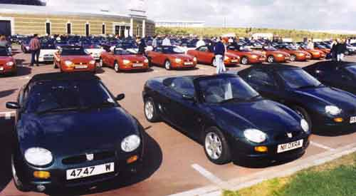
1996 MGF birthday celebration held at Gaydon
The early days of the Register were taken up with trying to find out more about what the new owners wanted out of our Club. The committee had grown to include MG dealer John Priest of Chesham, and two more owners, Graeme Bishko and, thankfully, another blonde female, Caroline Woodley. The Daily Telegraph must have been on the run by now as not one of the team met their specification!
At the Club’s annual festival at Silverstone in 1996, Julia had decided to find out more about our growing membership, by now running at around 400, and produced a brief questionnaire to help guide us forward. In spite of a knee injury and being on crutches, she hobbled around the parking area making sure that we found out what we needed to know. It became quite clear that F members were outgoing and sociable and wanted to use their cars for pleasure, which is driving around as part of an event, or to get to an event. Many had already 'met' via the Internet with a bulletin board being the meeting place and this was the major feature of the research: nearly all of those we spoke to were email friendly and were regularly trawling the 'net. This feature also governed the future shape of the committee who, were all 'net jockeys'. Remember that this was the early days of the Internet.
The Register continued to grow. The availability of less expensive used cars has widened the pool of potential members, as did the introduction of a lower-priced entry model with 1600cc engine. Since launch and up to the end of 2000, well over 33,000 had been sold in the UK, with a further 30,000 abroad. No other sports car had sold in these numbers in the home market up to September 23, 1995 when MG returned to selling sports cars. By the end of production of MGF, over 77,000 had been produced and it was superseded by a conventionally suspended MG TF a model which was put back into production by NAC for a limited period, producing less than 1,000 before SAIC turned off the tap.
Following the dark days of 1980, when the Abingdon factory closed, we could have become just another old car club. However, the arrival of the Metro, Maestro and Montego in the middle '80s, and the RV8 in the early 90s, had given the Club a much-needed boost in membership. The MGF and TF have increased the activity in the social scene behind the sporting side of Register activities and have, in the period since the original launch, added around 3,500 people to our Club.
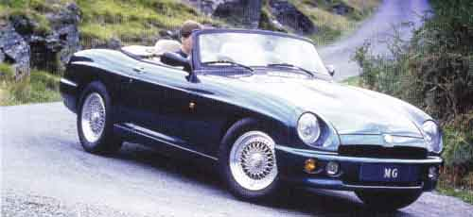The RV8 gave the Club a membership boost before the MGF was launched
Year 2001 and beyond, has provided us with a startling range of new products from the Longbridge factory to admire, from the appropriately renamed MG Rover Group. This was another opportunity to encourage new members to our ranks in the same way that the MGF had done. SAIC continued to produce new models, using the Longbridge facilities to assemble MGs up until recently.
My tenure of the Chairmanship of the MGCC finished in 2005, having been appointed five years earlier, and I had been looking for gainful employment since the April of that year following the collapse of MG Rover Group.
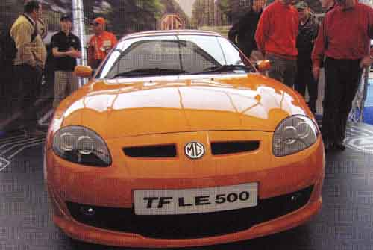
The NAC MG TF LE 500 on display at Silverstone in 2007
Stephen Cox was a long-standing member of the Club. Having been the scribe for the Midland Centre, he became Treasurer of the MGA Twin Cam Group following the acquisition of a Coupe model and in that position, he attended council meetings with Nick Cox. After a period as Club director he became chairman from 2000-2005. He competed with an MGF in the Abingdon Trophy and progressed to race in other Club championships. During this time, he became involved in the MG Sport and Racing development process, moved on in 2003 to work with Tatra Motors on a joint project to import their utility products to the UK. In 2006 he returned to the world of MG at Longbridge as Sales and Franchising Manager for the Nanjing Automobile Corporation who had purchased all the assets of the failed company. Stephen now lives in France.
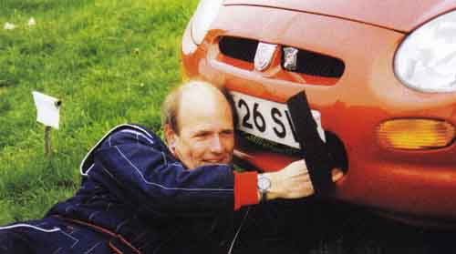
Stephen Cox and his MGF

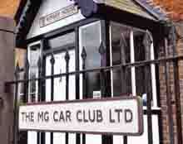
Until 1997 the office administration of the Club had been carried out by a series of female administrators who handled the day-to-day running of the office and carried out specific work directed by the members of the Board.
The fact that most of them served the Club for many years (for example Lyn Jeffery 1990-1997) is an indication that the arrangement worked efficiently and smoothly. Jean Bryce served as Membership Secretary for over 20 years.
In August 1997, however; the Board decided that the time had come for Kimber House to bring considerably more responsibilities 'in house'. It was felt that this now required the appointment of a full-time Chief Executive, a position which was filled by Rob Gammage.
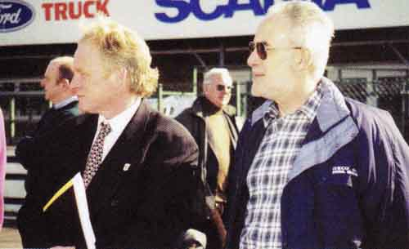
Rob Gammage (left) and Roger Latham (Anglia Centre)
The office was soon to handle competitions, an improved membership department, Safety Fast! production, a new computerised accounting system, the appointment of an exhibition organiser and generally improved services to Centres, Branches and Registers. The new Chief Executive was given a fairly free hand to be proactive with new projects, at the same time keeping the Board and the Council up to date with developments.
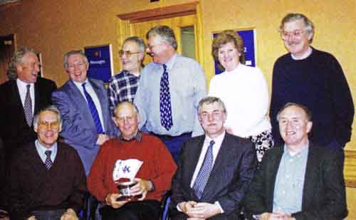
Rob Gammage with the 1998 MGCC Competitions Department. Ron Gammons to the left.
Inevitably, the increase in membership and Club activities meant that more office accommodation was soon required at Kimber House (formerly No 12 Cemetery Road). With its small cottage-style rooms, a lot more space was needed for the new members of staff. The Board negotiated the purchase of the adjoining cottage No 11, which had been the residence of an elderly couple who had lived there for many years. A mutually amicable arrangement was agreed whereby the Club would arrange for them to be rehoused in a bungalow in Cornwall where they planned to retire. The purchase of the bungalow by the Club was seen as a maturing asset and the financial arrangements were successfully completed.
Under the successive Chairmanship of Mike Hawke, Peter Best and Stephen Cox, the Club was set to enjoy a period of modernisation and consolidation. At Kimber House, competitions were now handled by Peter Browning. John lnness was appointed exhibition manager, and lan Rendle (Safety Fast! production) handed over to Andy Knott.
The year 1997 produced a trading surplus with increased membership and the 100,000th member soon to join. In I999 Classic Car magazine awarded MGCC Silverstone best club event of the year - the second time in three years. In 2000, the Club of the Year Award from Classic & Sports Car magazine celebrated the 75th anniversary, over 300 annual events in the UK and a growing membership worldwide. In 2001, after 16 years, Paddy Willmer retired as editor of Safety Fast! handing over to Peter Browning.
Celebrating anniversaries proved to be good promotion and an opportunity for special events. Safety Fast! in March 2003 recorded 75 years of the M Type, the 40th Anniversary of the T Register, 30 Years of the MGB VB, the 25th Anniversary of the VB Register, 20 years of the Maestro and the 20th Regency Run (London to Brighton) which attracted over 700 cars. The year 2003 also saw the formation of the new TRZS|ZT Register.
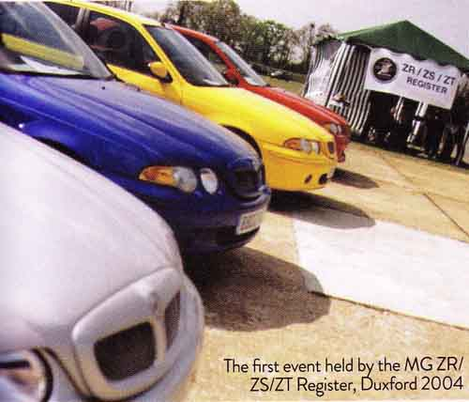
First event by the MG ZR/ZS/ZT Register, Duxford 2004
The growing popularity of Track Days, where enthusiasts could bring their road cars to sample circuit driving, prompted the Club to set up its own MGs on Track operation. Originally inspired by Dave Livingstone at the start of the 2004 season, the Club's Track Days soon became regular events enjoyed by a growing number of members.
It was during 2004 that controversial plans were drawn up for the building of a modern purpose-built office to replace Kimber House. This ambitious project caused considerable controversy and was finally shelved on the basis that the cost would involve spending a huge chunk of the Club’s financial assets, which were probably unlikely to have been recovered by increased business.
Towards the end of 2005 the Board discussed a proposal that Safety Fast! should be downsized to include only Club news, while feature material would be incorporated into the long-established magazine MG Enthusiast which would be mailed to members. This was not generally popular; there were administrative problems and the arrangement was soon terminated and Safety Fast! was reinstated in July 2007.
The Club's financial position has always been reflected in the strength of membership, particularly new members, and this has always been linked to the availability of new MGs. The closure of MG Rover at Longbridge in 2005 was to see a serious drop in membership income as the production of MGs came to an end. By 2006 the Club's finances were not strong and a serious reduction in activities like the racing programme had to be made.
The year 2007 was to see many staff changes. Treasurer Peter Buckles stood down and Andy Knott took over as Safety Fast! editor from Peter Browning who retired. Rob Gammage moved on, the Club appointing Richard Jones as the new General Manager. Richard worked in the area of business development in motorsport and raced an MGF. Steve Carr joined the staff as the new Competitions Secretary. John Day took over as Chairman from Peter Best. Richard Jones left after only one year to be replaced by Julian White as the new General Manager in January 2009.
Much to my delight, I was offered the role of General Manager of the MG Car Club and started with the Club in January 2009.
Whilst the Directors had tried their best to brief me beforehand, never in my wildest dreams had I envisaged the complexity of the position and the opportunities that would be presented to me over the course of the coming years.
A lot has changed at the Club in recent years. Most importantly, we pushed ahead with the John Thornley suite which opened in June 2010 funded entirely through membership. This is a fantastic purpose-built meeting room allowing us to hold talks, film shows and other Car Club events. This heralded a new open-door policy, whereby we invited our members and other interested parties to visit Kimber House, primarily to view our growing archive collection but also feel the real spirit of MG that is Kimber House.
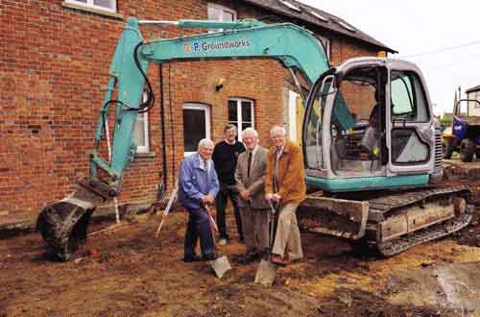
MG Abingdon factory employees at the groundbreaking for the John Thornley Suite
More recently, we got ourselves involved with a new 'MG garden' here in Abingdon, with the Car Club providing a timeline of MG's history.
My appointment as GM coincided pretty much with the launch of the first new SAIC MG, the MG6, in China and at the point where SAIC (Shanghai Automotive Industrial Corporation) were beginning to step up their MG presence around the world.
We had, I was told, already had a delegation of press members and senior figures from SAIC from China visiting Kimber House, shortly before I joined. Nobody was more surprised than me when a call came out of the blue inviting me out to Shanghai.
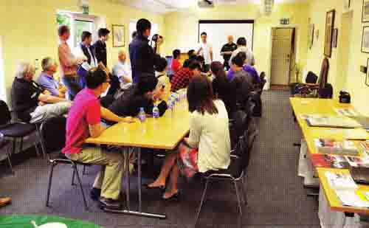Julian welcomes Chinese journalists to Kimber House in the John Thornley Suite
After sorting out the necessary visas, I was invited to go out to Shanghai departing on October 16, 2010. This was to be the first of a number of regular trips I was to make over the next few years.
I arrived in Shanghai in the company of Richard Monk, my opposite number with the MG Owners' Club. At the time, neither Richard nor I had much idea why we were wanted. I had been told in advance that they would like me to make a short presentation to the press and senior figures from SAIC about the history of MG and the MG Car Club. This was all to take place in a pavilion at the Shanghai Expo 2010, a huge world trade exhibition
When the day arrived, I made my speech alongside the then British Consul for Shanghai. Despite my nerves all went well. Shortly after, Richard Monk and I were asked to attend a press conference with about 20 journalists. It soon became apparent that they were particularly interested in the MG Car Club and the history of MG. This made me think that I should seize the opportunity to more closely align ourselves with the brand's current owners.
The following day I had a meeting with Ms Emmy Lin (MG and Rover Marketing Director) and her colleague, Phil Feija. We discussed various ways we could be of benefit to one another going forward; not least, I explained my vision that they should get involved with our international event at Silverstone, MGLive!, helping to align ownership with MG Car Club membership.
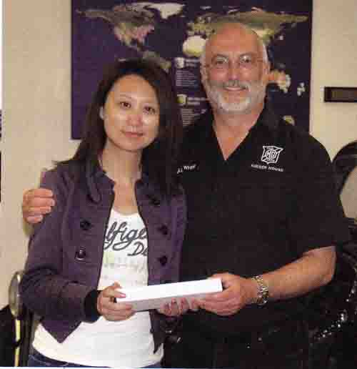
Julian White with Ms Emmy Lin
In the months that followed, various communications went backwards and forwards between ourselves and MG China, out of which we honed a 'heritage partnership'. This would include an agreed scope of work, in exchange for some financial support from them. This was to fund an additional team member at Kimber House and ongoing support with MG Live!. Our consultancy role would in turn help them with translation of brochures and other bits of literature, as well as supporting new car launches and, as importantly, correcting any historical inaccuracies.
This relationship has evolved further over a period of time. Both members of the Kimber House team and I are invited out to China, generally at least once a year, to attend new car launches and strategic meetings concerning MG worldwide.
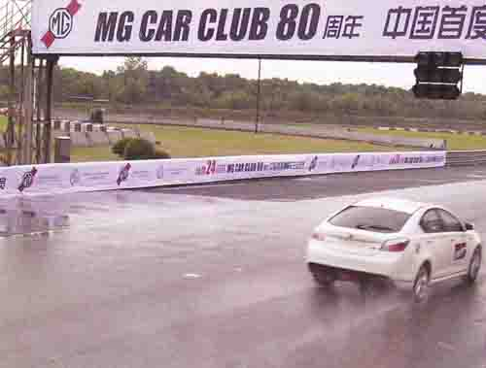
MG China celebrate the 80th anniversary of the MG in Shanghai
Back here in the UK, our relationship with MG UK continues to strengthen, with two cars currently available - the MG6 and smaller MG3 - and of course the Club supporting our newest register, the MG635 Register.
At Kimber House, in more recent times, we have hosted a number of reunions for the Abingdon MG workers, and more recently have held a presentation day for our members who have achieved 50 years' membership of the Club.
We continue to forge close links with both local and national museums; indeed, as I write this, the Abingdon County Museum has a permanent MG display demonstrating the importance of MG to local commerce, and of course the families whose living was made within the factory.
Finally, I think it worth mentioning that we continue to work closely with a number of MG-related businesses, both locally and nationally, enjoying sponsorship and dedicated support from a number of them.
I was very sorry to have to stand down as General Manager in 2015 through ill health but will always remember my time at Kimber House.
Over its 86 years, the MG Car Club has seen many changes, from the creation of British Leyland, the closure of Abingdon and, perhaps the biggest change, MG's move from British to Chinese ownership.
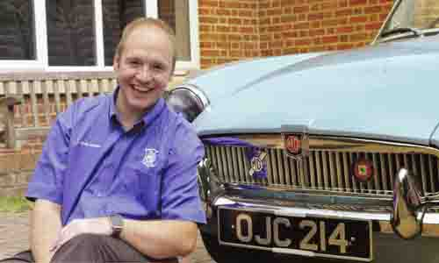
Adam Sloman, General Manager of the MGCC
And, while those changes have been huge, the world around us has changed too. The rise of the internet and social media sites means that the connection between people locally, nationally and globally has changed massively - where people might once have relied upon Safety Fast! dropping through their letterbox to be kept up-to-date with latest news from the Club, today that information is at their fingertips and is instantly available.
And, while it is fantastic to have such easy access to such information, it has created a plethora of alternatives to the MG Car Club, many of which are free of charge.
So, the challenge to the Club during this period is how to remain relevant to our existing members and how do we attract new ones?
The Club has been proactive in engaging in social media platforms such as Facebook and Twitter, as well as creating video content for the likes of YouTube and audio content via the Club's fledgling Safety Fast! podcast.
In order to justify our existence as we move forward, the Club needs to be proactive in all areas - most notably in support of MG s parent company, Shanghai Automotive industrial Corporation, and with tangible support of each new MG model.
Since Julian's efforts to establish a relationship with SAIC and assist in the creation of the MG Car Club China, Kimber House has worked with SAIC tirelessly – supporting model launches across the globe, as well as attending events in China, South America and the Middle East.
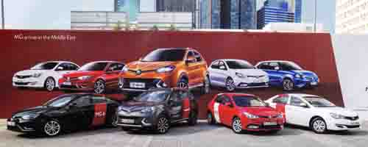MG arrives in the Middle East
The MG Car Club continues to enjoy a strong partnership with SAIC, serving as World Heritage Partner to the company, playing a vital role in protecting the heritage and history for the current generation and future generations.
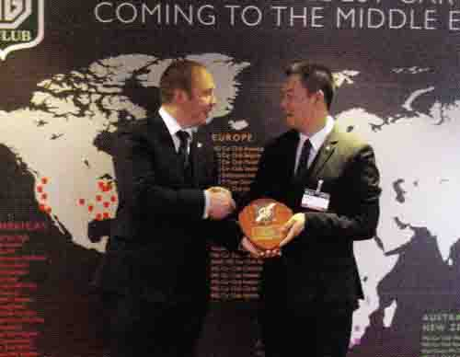Adam makes a presentation in Dubai
And it is that sense of protection that led to the Club's decision to begin a project to construct a new archive facility at Kimber House - a facility that eventually became known as the Bill Wallis Wing. Led by Dave Saunders, the Bill Wallis Wing’s design process began in 2015, with construction starting late that year. The plan was simple: to create an archive facility capable of protecting the Club’s enviable collection for many years to come, as well as adding further display and library space.
The extension was designed by member Maurice Standish, who worked together with Dave to identify an appropriate building firm, Ultimately, Morris and Blunt were selected to carry out the project and building work began in October 2015, with the official opening of the wing in May 2016 being presided over by June Wallis and daughter, Louise.
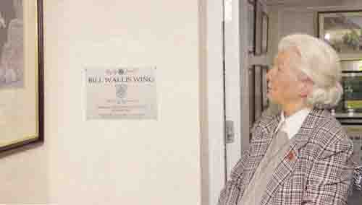June Wallis opens the Bill Wallis wing in 2016
The new archive room is equipped with state-of-the-art moving racking, capable of storing up to 23 tonnes of material. With an ever-growing collection, it is vital that the archive is as future-proof as possible. Upstairs, the two single offices have been remodelled to create a large double office, while the room above the Club's archive plays host to the Kimber House Library.
The project was completed on time and serves as a testament to the efforts of both Dave and Maurice, providing an outstanding facility to the Club that will be enjoyed by members for decades to come.
Drawing this most recent period of MG and MGCC history to a close is the announcement of the end of MG production at the Longbridge plant in Birmingham, bringing 92 years of MG history to a close - the future will see all MGs built abroad for the first time in the marque's history. With MG now very much part of a truly global family, we cannot expect UK production to happen, though we all hoped that one day Longbridge might be producing cars in its 1000s once again.
Despite the changes in MG's production, we can all take comfort that, as always, the MG Car Club will continue to endure and, with an incredible membership at its heart, long may this continue.
This Club History series has been based on the late Mike Hawkes' book “The First Seventy Years”, published in 2001. This was the first complete history of the Club and was a truly major achievement by Mike. When the Club’s archive copy of the book was lost and the original production discs were found to be damaged, it was decided to feature an updated and enlarged version to run in Safety Fast! - this month brings the story up to date. Thanks are due to those who have contributed new material, to Andy Knott who has led the production team and Peter Neal who has helped gather the new collection of photos. Finally, a special thanks to those past members who regularly contributed Club news in the pages of the MG Magazine, The Sports Car and Safety Fast! who recorded the all-important early years of the Club.

NAMGAR would like to thank Andy Knott, Editor, Safety Fast! for his kind permission to reproduce these articles.

